From: <https://www.revolver.news/2021/12/damning-new-details-massive-web-unindicted-operators-january-6/>

Meet Ray Epps, Part 2: Damning New Details Emerge Exposing Massive Web Of Unindicted Operators At The Heart Of January 6

December 18, 2021 (6mo ago)

Meet Ray Epps, Part 2: Damning New Details Emerge Exposing Massive Web Of Unindicted Operators At The Heart Of January 6

Six weeks ago [On October 25, 2021, See [Part 1, here](http://chasegalleryconnect.org/FNC_C/Data/Our%20World/Conspiracy%20Theories/J6%20Capitol%20Breach/Meet%20Ray%20Epps,%20Fed-Protected%20Provocateur%20Who%20Appears%20To%20Have%20Led%20The%20Very%20First%20Jan%206%20Attack%20On%20U.S.%20Capitol.htm).] Revolver News published a [blockbuster investigative report](https://www.revolver.news/2021/10/meet-ray-epps-the-fed-protected-provocateur-who-appears-to-have-led-the-very-first-1-6-attack-on-the-u-s-capitol/) on Ray Epps — a man who, more than any other individual, appears to be the key unlocking the question of active federal involvement in the so-called “Capitol Siege” of January 6th.

Out of all of the thousands of January 6’s protesters, and the thousands of hours of publicly available footage from that fateful day, Ray Epps has turned out to be perhaps the only person nailed dead to rights confessing on camera to plotting a pre-planned attack on the Capitol. On both January 5 and January 6, Epps announced multiple times, at multiple locations, his upcoming plot to breach the US Capitol. He then spent hours attempting to recruit hundreds of others to join him. On top of it all, Epps was seen leading key people and managing key aspects of the initial breach of the Capitol grounds himself.

Watch:  
[At this point there's a 1min 27sec clip showing a time-series of most (all?) of the James Ray Epps important (famous) footage. It is still available [here](https://www.revolver.news/2021/12/damning-new-details-massive-web-unindicted-operators-january-6/) on 20220615. –FNC]

It would be one thing if Epps’s repeated calls on January 5 to “go into the Capitol” had simply amounted to bluster. But Epps followed through on his stated mission to shepherd others inside. In clips 4-6 of the above compilation, we see Epps actively orchestrate elements of the very first breach of the Capitol barricades at 12:50 p.m, while Trump still had [20 minutes left](https://www.lifesitenews.com/news/capitol-riot-on-jan-6-began-already-30-minutes-before-trumps-speech-ended/) in his rally speech.

It is noteworthy that this Ray Epps breach occurs [just one minute](https://en.wikipedia.org/wiki/Timeline_of_the_2021_United_States_Capitol_attack) after Capitol Police began responding to reports of two “pipe bombs” located at DNC and GOP headquarters, respectively. Rather conveniently, the already-handicapped Capitol Police thus had still-fewer resources with which to respond to the barricade breach in question.

While the “pipe bombs” turned out to be a dud, the Ray Epps breach proved fateful. Today, the official stories told by the [New York Times](https://www.youtube.com/watch?v=jWJVMoe7OY0&t=638s), the [Wall Street Journal](https://www.youtube.com/watch?v=n0MA5GjR6Zo&t=317s), and the [US Justice Department](https://www.justice.gov/opa/page/file/1362781/download#page=4) all depict the apparent Ray Epps-orchestrated 12:50 p.m. initial breach of metal barricades as the “Big Bang” event of January 6.

In large part, this description is hardly an exaggeration. **Indeed, it was the 12:50 p.m. breach of the Capitol grounds, in conjunction with a**[**handful of suspicious individuals ripping down fencing and signage**](https://rumble.com/vo7igb-ray-epps-the-moment-the-16-police-barricades-were-first-stormed.html)**, that set in motion the conditions allowing for 1/6 to turn from a rally into a riot.**

**In this report, we will blow open this network of still-unindicted key operators who appear to have been at work either with or around Ray Epps during the initial Capitol grounds breach. You, dear reader, will be scandalized — though perhaps unsurprised — to learn that none of the actors covered in this report have received attention in the mainstream press, despite their active and indispensable roles in the events of 1/6.**

As we explained in detail in our previous report, the FBI originally put Ray Epps’s face on its Capitol Violence “Most Wanted List” on January 8, 2021, just two days after 1/6. They offered a [cash reward](https://archive.fo/h4i8P) for information leading to his arrest. In fact, rank-and-file FBI agents initially deemed Epps’s role as an apparent riot organizer so important that they named him Suspect #16—one of the first 20 high-profile FBI targets in a database now packed with more than 500 suspects.

Then, six months later on June 30, 2021, both [Revolver News](https://www.revolver.news/2021/06/stewart-rhodes-oath-keepers-missing-link-fbi-unindicted-co-conspirator/) and [The New York Times](https://archive.fo/eDlzs#selection-1047.0-1059.355) published inconvenient stories that encouraged a more aggressive interrogation of the “Ray Epps third rail,” leading reasonable people to wonder why this publicly identified man on the Most Wanted List still had no charges filed against him.

The FBI responded to these important media stories the very next day. But their response was to [quietly purge](https://www.revolver.news/2021/10/meet-ray-epps-the-fed-protected-provocateur-who-appears-to-have-led-the-very-first-1-6-attack-on-the-u-s-capitol/) all online Ray Epps files from their website, then switch to a posture of “What? Who? Ray Epps? Never heard of him.”

Agents of the FBI Field Office in Phoenix (where Epps lives) have gone so far as to [explicitly deny knowledge](https://rumble.com/vql3so-phoenix-fbi-agents-visit-pure-politics-deny-knowing-ray-epps-exists.html) that Ray Epps even exists. Instead of pursuing Epps, [FBI agents have instead pursued journalists](https://rumble.com/vql3so-phoenix-fbi-agents-visit-pure-politics-deny-knowing-ray-epps-exists.html) who had the temerity to ask Epps in person if he was a government operative. “I understand that, but I can’t say anything,” is all Epps would [tell](https://rumble.com/voc5ev-fed-ray-epps-confronted-and-scurries-away-cowards-always-run.html) them.

Here’s a quick visual synopsis of this timeline:

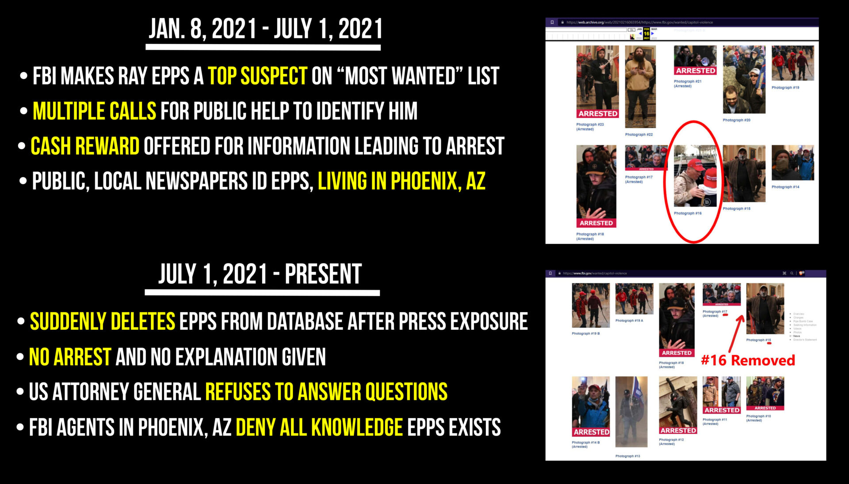

The sham Congressional January 6 Commission seems to be going along with the charade of Ray Epps denialism. For all of its recent gesticulations about [Mark Meadows’s benign text messages](https://www.npr.org/2021/12/13/1063955835/rep-liz-cheney-read-text-messages-she-said-mark-meadows-got-during-the-jan-6-sie), the Commission has yet to express even a basic interest in Ray Epps or his communications leading up to and on January 6.

But the specter of Ray Epps, and the ominous questions his immunity raises, loom too large to be memory-holed by poorly coordinated efforts of government denial. In light of the above, it is both amusing and symbolically appropriate that despite the FBI’s attempt to purge Epps’s face from its “Wanted” database (and public denials of his existence from authorized agents), the FBI DC Field Office still features Ray Epps as a “Wanted” man in its [current pinned Twitter image](https://twitter.com/FBIWFO) (look closely and you’ll find it).

**If Epps turns out to have been some kind of government operative, which at present is the only clean and simple explanation for his immunity, it is game over for the official “MAGA insurrection” narrative of 1/6. Epps was the day’s loudest riot recruiter, and its apparent leader of the very first breach of Capitol grounds. If Ray Epps is a Fed, the “Insurrection” becomes the “Fedsurrection” in one fell swoop.**

These are the stakes at play in unraveling the Ray Epps enigma.

**But it is imperative to note that if Epps was just a cog in a much larger federal operation, he would not have been deployed alone. Historically speaking, when Feds have**[**orchestrated fake mobs of fake protesters**](https://theintercept.com/2020/06/02/history-united-states-government-infiltration-protests/)**, or contrived fake conspiratorial plots, the Feds’ own assets have commonly comprised between 16% to 25% of the plot’s participants, at least in its key respects. Indeed,**[**the FBI once flew in 1,600 rowdy spooks**](https://caityjohnstone.medium.com/nothing-is-certain-but-death-taxes-and-police-infiltration-of-us-protests-b234e022b137)**to infiltrate a single convention with just 10,000 protesters.**

In recent times, attacks blamed on right-wing militias have blown past the 16% mark on the Fed Saturation Index and have been clocking in at a whopping 25-50%. As Revolver has [previously noted:](https://www.revolver.news/2021/10/meet-ray-epps-the-fed-protected-provocateur-who-appears-to-have-led-the-very-first-1-6-attack-on-the-u-s-capitol/#close-modal)

Students of FBI history should quickly absorb the lesson that infiltrating Feds are like roaches: whenever you spot one, it is guaranteed there are dozens of others nearby. Feds simply never, ever, operate alone. This is how you end up with at least [12 FBI informants](https://archive.fo/o/7qOae/https:/www.buzzfeednews.com/article/jessicagarrison/fbi-informants-in-michigan-kidnap-plot) in a tiny “right-wing” Michigan militia plot from October 2020 (that’s just informants, not even agents), [15 informants](https://archive.fo/o/7qOae/https:/www.oregonlive.com/oregon-standoff/2016/10/15_confidential_sources_fed_fb.html) in the “right-wing” 2016 Malheur plot, dozens in the 2014 Bundy Ranch affair — [including six FBI undercover agents posing as fake documentarians shooting a fake documentary](https://archive.fo/o/7qOae/https:/theintercept.com/2017/05/16/the-bizarre-story-behind-the-fbis-fake-documentary-about-the-bundy-family/) — and the list goes on.

So if Ray Epps was instructed by the government to play his part in various recruiting, breaching and crowd control efforts that day, we would expect many other informants to be set up around him.

To test this hypothesis, Revolver spent the past six weeks comprehensively mapping Ray Epps’s network of interactions on January 6, and profiling the key people around him who complemented his efforts. We did a deep dive into other key figures involved in the initial breach of the Capitol grounds, as well as figures who played an instrumental role in fence removal and crowd control. In short, we investigated key players whose early actions on 1/6 turned the rally into a riot.

The bad news for Fedsurrection Deniers is the results are in, and they look even worse for the FBI than Revolver’s already low expectations. For brevity, we profile five of the most egregious cases in this report, and tell the story of how they crossed paths and interacted with, and **in some cases coordinated with Ray Epps to make 1/6 possible.** Some of these cases are so wild as to constitute Epps-sized scandals unto themselves.

But first, it important to note that Feds at the mere informant level are seldom told by their handlers of the presence of other government informants around them. From each individual informant’s perspective, the agitators around them would look as lawless to them as they did to the crowd.

[This exact strange situation](https://www.justice.gov/opa/press-release/file/1326171/download#page=13) played out in the climax of the Whitmer Kidnapping Plot. The car that prosecutors say “cased” the Governor’s house had five passengers—two homeless patsies, and [three secret Feds](https://imgur.com/a/H7uspNJ). But only the agent-level Fed in the car had total operational awareness. Each of the two informants in the car probably thought the other was a legitimate insurrectionist.

So it is not necessary for all or any of the individuals covered in this report to know each other or to have affirmatively “worked together” to have formed a “team” through collective effort. A simple text message from a federal handler to “Be at the Peace Monument at 12:45 p.m. and [flush out the crazies](https://web.archive.org/web/20091202065420/http:/www.northjersey.com/news/Records_show_feds_used_ultra-right_radio_host_for_years.html)” would be all that’s needed for a large ring of provocateurs to simultaneously be in the same place, at the same time, contributing to the same breach.

**So now, without further ado, we will tell the true, documented story of 1/6 that the Regime doesn’t want you to hear, involving key unindicted figures the Regime would prefer that you never heard of.**

If there were such a thing as an unbiased January 6 Commission that sought to piece together the accurate timeline and narrative of events on 1/6, the following study would be the sort of thing it would publish.

Revolver makes no facial allegation about any of the individuals below. However, some very serious, shocking and time-sensitive questions are raised by this report. To that extent, our accusations and demands are aimed squarely at the US Justice Department.

FBI Director Chris Wray and Attorney General Merrick Garland have an awful lot of explaining to do.

**The Booby Trap that Turned a Rally into a Riot**

Before we get acquainted with the key unindicted players operating around Ray Epps, let’s quickly touch upon the basic facts of the initial breach of the Capitol grounds.

The “Big Bang” moment that kicked off the riot was when a small “breach team” of just a few dozen people violently knocked over the first set of metal barricades between 12:50-12:53 p.m. They forced back the police, and therefore opened a clean walkway entrance to the crowd behind them.

We will hereafter refer to this location of barriers as the “Ray Epps breach site,” and the collection of individuals responsible for this critical initial breach as the “Ray Epps breach team.” Clips from that breach scene, with Ray Epps standing front and center giving out directions, are republished below for convenience.

Watch:[At this point there's a 43sec clip showing the breach team breaking through the police barricades. It is still available [here](https://www.revolver.news/2021/12/damning-new-details-massive-web-unindicted-operators-january-6/) on 20220615. –FNC]

This same breach team then proceeded to haul the metal police barricades off to the side, tear down “Restricted Area” signage, and systematically remove protective fencing from the Capitol lawn. Ordinarily, with no barriers in place, this entire area is [open to the public](https://www.revolver.news/2021/10/arrest-of-green-beret-oath-keeper-threatens-to-expose-fbis-darkest-1-6-secrets/).

To get a geographical sense of the Ray Epps crime scene, the below image shows where the Capitol’s rear barricades and fencing were first attacked. This area is also known as the Peace Monument.

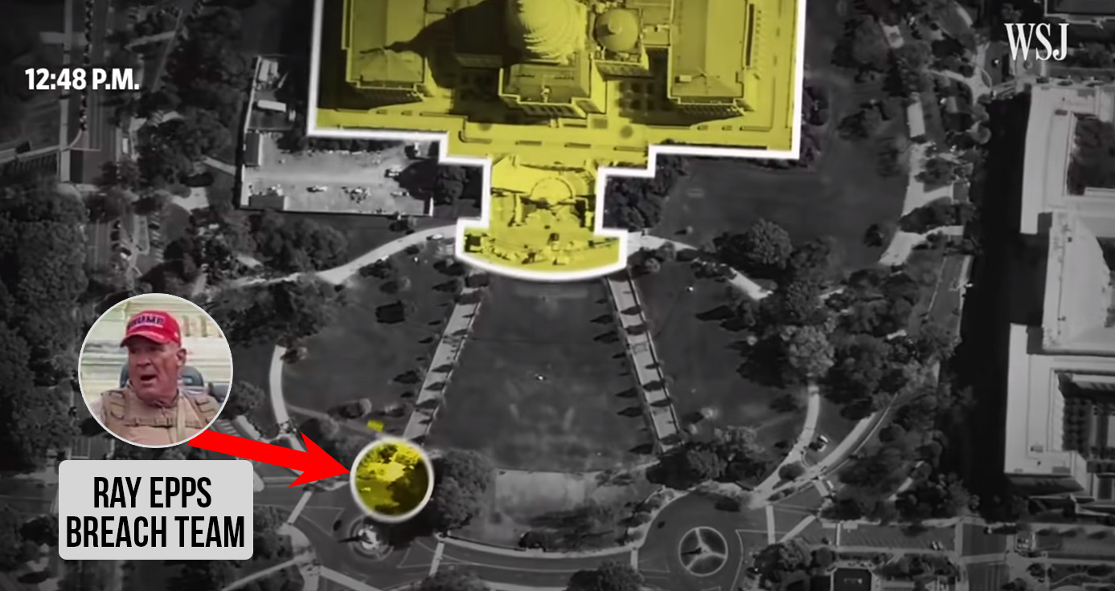

The tactical importance of this breached location is that it was [the very first walkway entrance](https://www.google.com/maps/dir/The+Ellipse,+Washington,+DC+20502/United+States+Capitol,+First+St+SE,+Washington,+DC+20004/@38.892699,-77.0315713,15z/data=!3m1!4b1!4m14!4m13!1m5!1m1!1s0x89b7b7a303eb5371:0x9acbbad2bbc35466!2m2!1d-77.0365825!2d38.8939876!1m5!1m1!1s0x89b7b82921a2cf17:0x482a3f7c10cf8c4!2m2!1d-77.0090505!2d38.8899389!3e2) into the Capitol grounds that every Trump supporter would arrive at first as they walked from the Trump rally to the Capitol.

The Ray Epps Breach Team had the amazing foresight to pry open the one walkway entrance that no one could avoid.

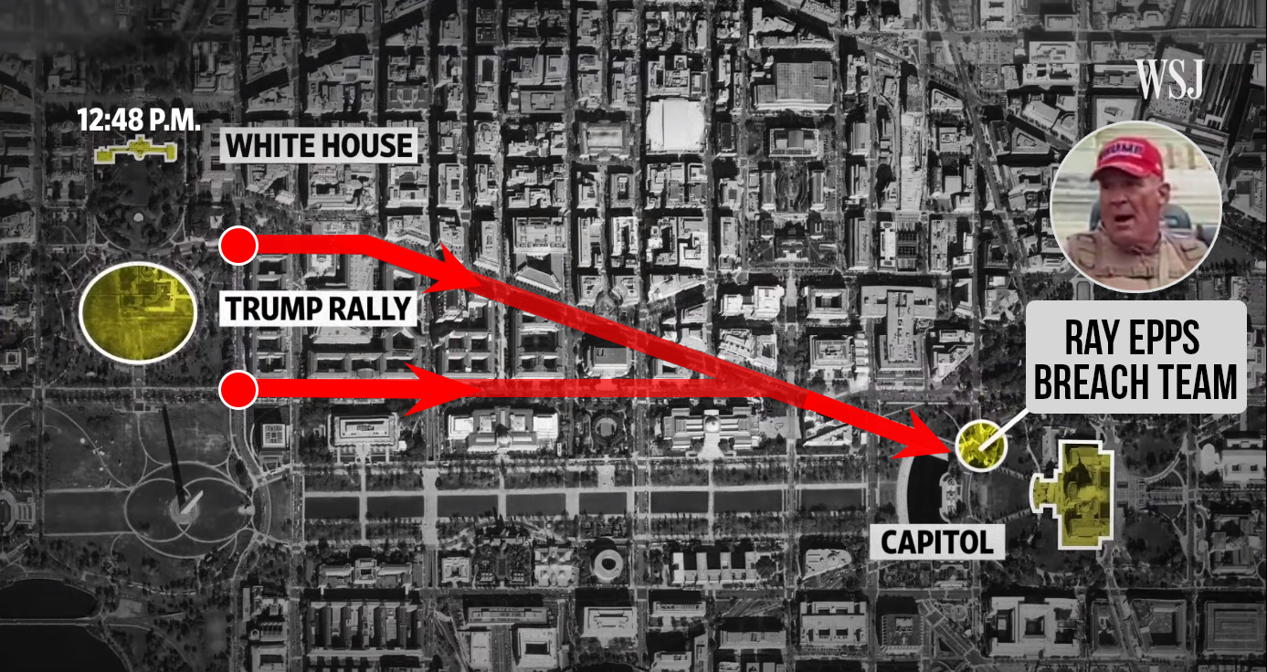

As you can see from the above, both the Pennsylvania Ave and the Constitution Ave exits from the Trump speech intersect at the exact Peace Monument barricade targeted in advance by the Ray Epps Breach Team. If any of the eight other walkway entrances into the Capitol grounds had been toppled instead, tens of thousands of marchers would have been met by police and metal barricades, instead of an open gate.

The Ray Epps breach team thus [set up a booby trap](https://www.revolver.news/2021/10/arrest-of-green-beret-oath-keeper-threatens-to-expose-fbis-darkest-1-6-secrets/) by

1. pushing back the police, then hauling away
2. the “restricted area” signage,
3. the chain fencing, and the metal barricades

—all while tens of thousands were still at the Trump rally.

Without police present or “do not enter” signs prominently visible, people leaving Trump’s speech and arriving at the Capitol entrance would have no idea it was illegal to walk through the gate, or onto the lawn, or up to the Capitol steps. After all, this entire area is ordinarily open to the public.

Instead, they heard friendly music and saw the main walkway to the Capitol grounds wide open. These unwitting Trump supporters had no idea they had just crossed an invisible tripwire that would later subject them to federal prosecution for trespassing.

Watch: [At this point there's a 42sec clip showing little or no evidence that this area had been restricted. It is still available [here](https://www.revolver.news/2021/12/damning-new-details-massive-web-unindicted-operators-january-6/) on 20220615. –FNC]

Moreover, the giant main component of Trump protesters would not arrive at this Capitol entrance until 50 minutes after the Ray Epps Breach Team opened up the walkway—Trump had 20 minutes left in his speech, and it took 30 minutes to walk to the Peace Monument. This giant component arrived at the entrance and saw hundreds of people already inside the Capitol grounds. They would no longer stage their protest back behind the fencing, because the Breach Team booby-trappers had already hauled most of it away before they got there. The giant component therefore walked all the way up to the Capitol building itself.

As we described in more detail in our [October 10 report](https://www.revolver.news/2021/10/arrest-of-green-beret-oath-keeper-threatens-to-expose-fbis-darkest-1-6-secrets/), the Ray Epps Breach Team thus set up what may amount to the largest legal booby-trap in American history.

Indeed, when the DOJ indicted Oath Keeper Jeremy Brown in September for “trespassing on restricted grounds” (18 US Code § 1752), the Justice Department explained that any January 6 protester who stepped foot within the red line below had committed a federal crime and could be kept in prison without bail until a criminal trial 12+ months away.

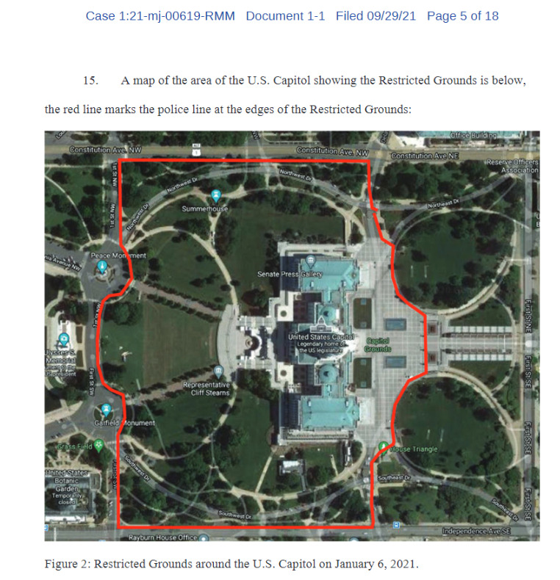

But how did this happen? Who exactly pulled it off? And how does it all trace back to Ray Epps?

**Setting Up The Booby Trap**

In our [October 10 Revolver report](https://www.revolver.news/2021/10/arrest-of-green-beret-oath-keeper-threatens-to-expose-fbis-darkest-1-6-secrets/), we showed January 6 footage of one dark-complected man coolly and methodically cutting down and then rolling up “restricted area” fencing around the Capitol lawn. He had no Trump gear on, and made sure to wear dark sunglasses on a cloudy day. He was not angry. He was dispassionate, calm, and professional, like he was just there to do a job.

Watch: [At this point there's a 16sec clip showing one dark-complected man coolly and methodically cutting down and then rolling up “restricted area” fencing around the Capitol lawn. It is still available [here](https://www.revolver.news/2021/12/damning-new-details-massive-web-unindicted-operators-january-6/) on 20220615. –FNC]

Here’s another picture to make perfectly clear what he was doing, and how strange and methodical it was:

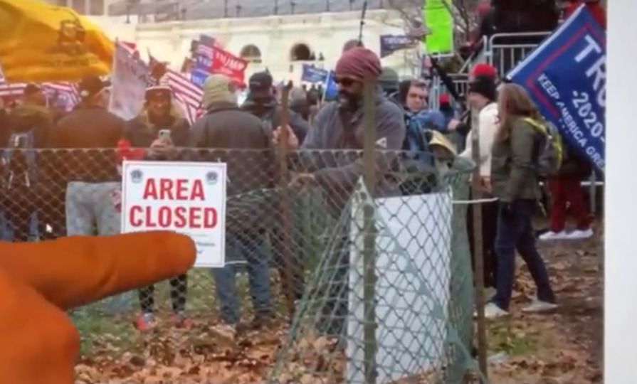

This man remains unindicted. In fact, the FBI [does not even appear to even be looking for him](https://www.fbi.gov/wanted/capitol-violence). He is wholly absent from the FBI Capitol “Most Wanted List.” There is no reward for information leading to his arrest.

For perspective, the FBI’s “Most Wanted List” features [plenty of MAGA grandmas and teens](https://imgur.com/a/t3lwq2u) who committed no property crimes or physical damage at all. For instance, you can still win a cash reward for information leading to the arrest of [FBI “Most Wanted” Suspect # 342](https://www.fbi.gov/wanted/capitol-violence-images/capitol-342b.jpg/view):

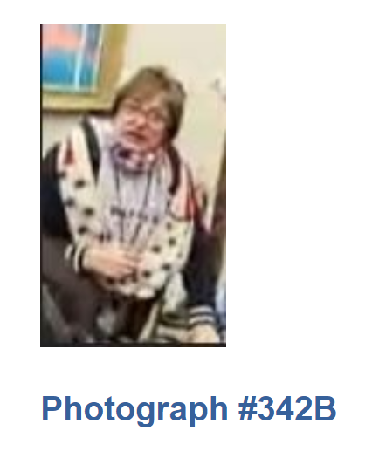

Despite the FBI’s lack of interest in this brazen booby-trapper seen rolling up restricted area fencing, online researchers have stayed on the case. They have dubbed this individual [“#FenceCutterBulwark”](https://jan6attack.com/individuals/fencecutterbulwark/), with “Bulwark” being the brand name of his fire-retardant jacket, designed for [professional use](https://www.frdepot.com/fr-outerwear/jackets-coats/) in the oil and gas industry. You’ll see more fire-retardant jackets among the unindicted below.

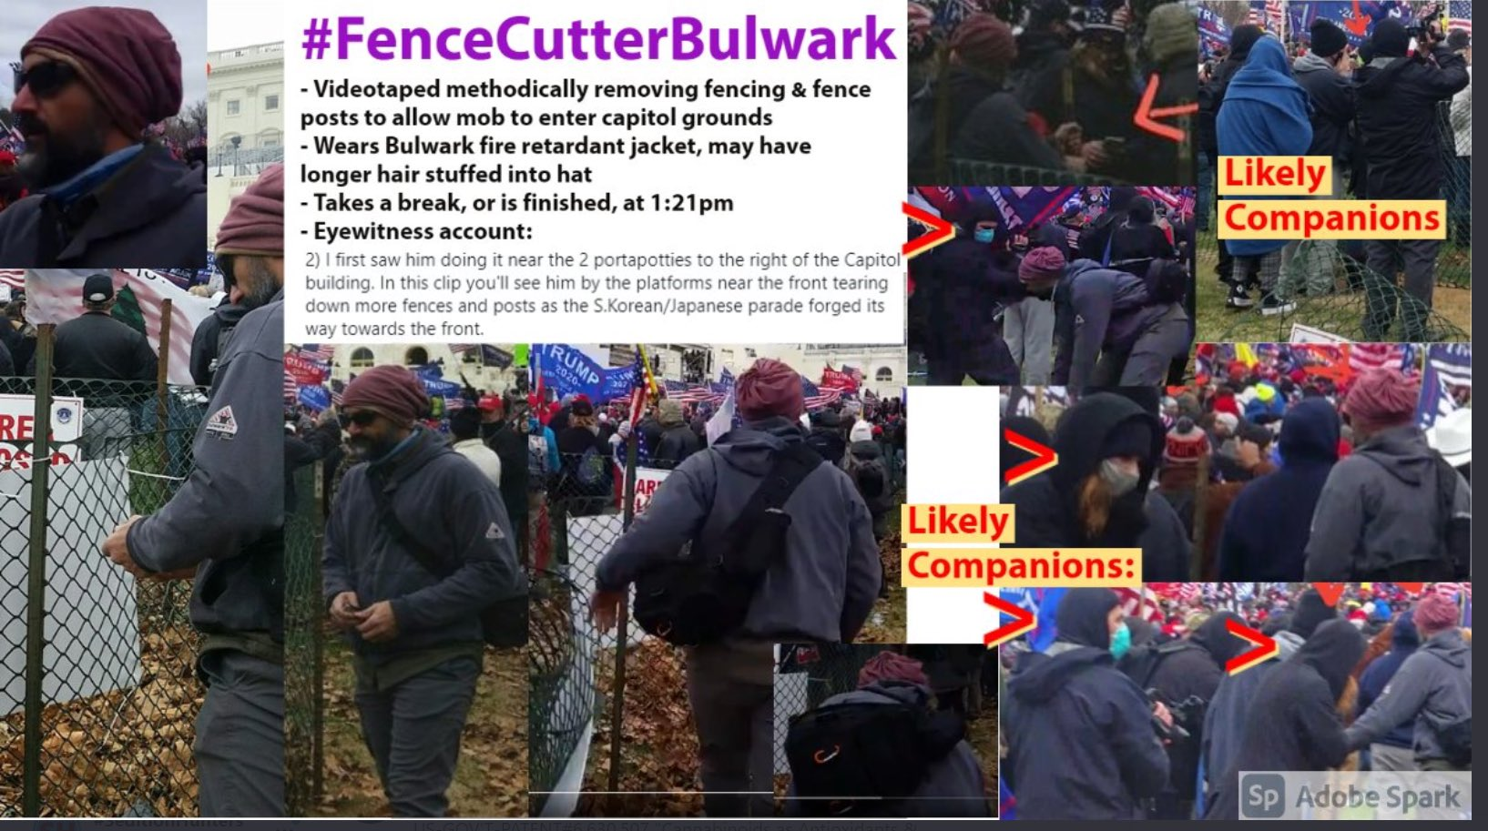

FenceCutterBulwark was waiting right next to the Ray Epps Breach Site at 12:31 p.m. That’s a full 20 minutes before the breach kicked off. There, he was doing nothing except [looking out past the fencing](https://www.youtube.com/watch?v=aJZHQpqjIbU&t=124s) he would later take down.

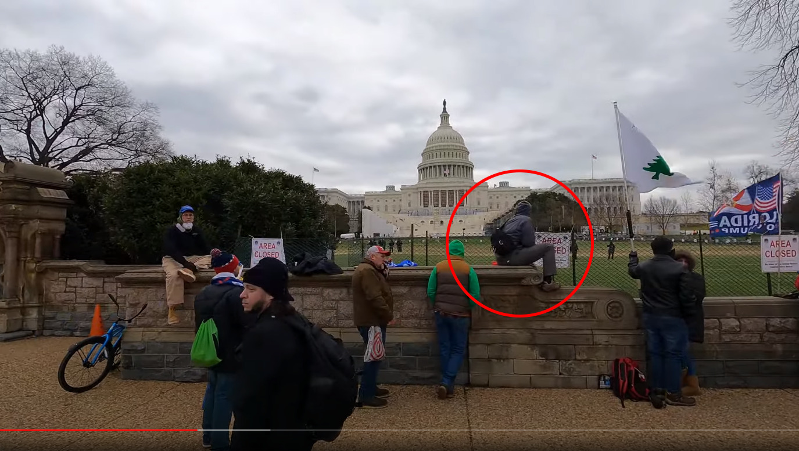

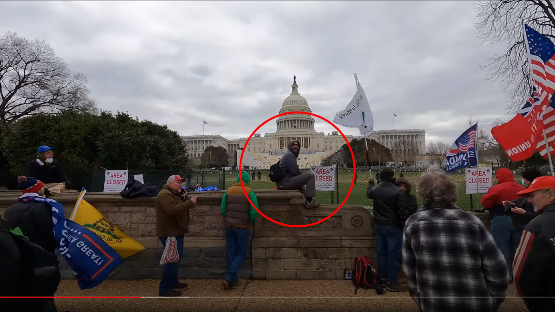

Moreover, 12:31 p.m. is 17 minutes *before* the large group of 220+ marching Proud Boys arrived at the Peace Monument from their lunch break. Here’s why that matters:

The official January 6 story, as parroted by the [New York Times](https://youtu.be/jWJVMoe7OY0?t=606), the [Wall Street Journal](https://www.youtube.com/watch?v=n0MA5GjR6Zo) and [HBO](https://www.youtube.com/watch?v=qlcdaAx5hu8), is that the Proud Boys’ arrival at the Peace Monument at 12:48 p.m. is what sparked a sudden breach. But the fact that FenceCutterBulwark and other key operators (until now ignored by mainstream media) were already waiting in place [while the Proud Boys’ were still a mile away eating lunch](https://youtu.be/oSOsG5kN5wc?t=3944) suggests a more sinister possibility: foreknowledge of an imminent breach at this exact location.

If it were just FenceCutterBulwark hanging out near the breach site before the Proud Boys’ arrival, we might chalk it up to coincidence. But the presence of multiple key breach figures waiting here seems too much to be coincidental. In the below video, continuously recorded between 12:40-12:50 p.m., you will see Ray Epps already in position at the exact walkway entrance the breach team will pry open, at least six minutes before they arrive (in fact, we know [he was there 45 minutes before](https://rumble.com/vo7gx1-ray-epps-when-we-go-in-leave-this-here.html) they arrived too).

Watch: [At this point there's a 5min32sec clip showing first The Proud Boys, then Ray Epps in position and finally briefly speaking to Ryan Samsel. It is still available [here](https://www.revolver.news/2021/12/damning-new-details-massive-web-unindicted-operators-january-6/) on 20220615. –FNC]

But it’s not just Ray Epps and FenceCutterBulwark who appear to have been waiting for the Proud Boys.

Perched right across from FenceCutterBulwark at 12:31 p.m. is the man widely regarded by online researchers as the most infamous of all unindicted January 6 riot leaders—a man unmentioned in the mainstream press but elevated to legendary status online as “[#NWScaffoldCommander.](https://jan6attack.com/individuals/nwscaffoldcommander/)”

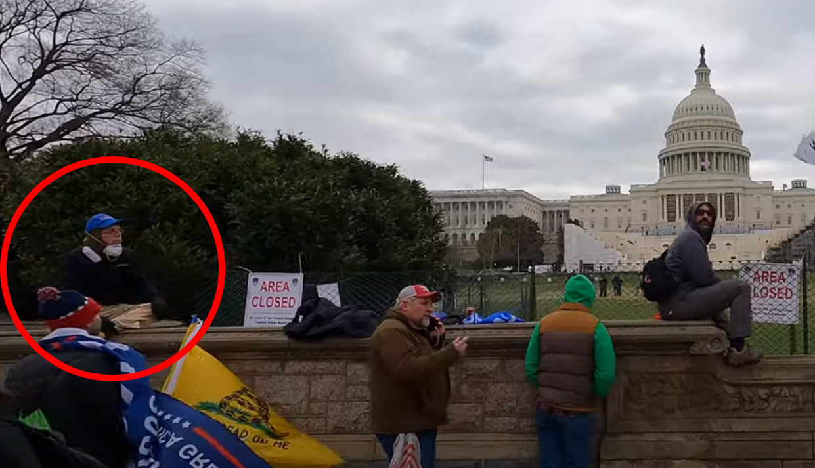

Don’t let looks deceive you: This extremely peculiar middle-aged man with glasses, a nerdy mask and a blue ballcap has been assigned more notoriety by deep researchers than arguably any other person of the thousands they have indexed. NWScaffoldCommander’s frenetic whirlwind of activities, and apparent role as “[the ringleader](https://twitter.com/Twinity5/status/1347346378545049600)” of the breach, have made him the subject of Russiagate-level rumor and speculation that he was privy to a January 6 “master plan.”

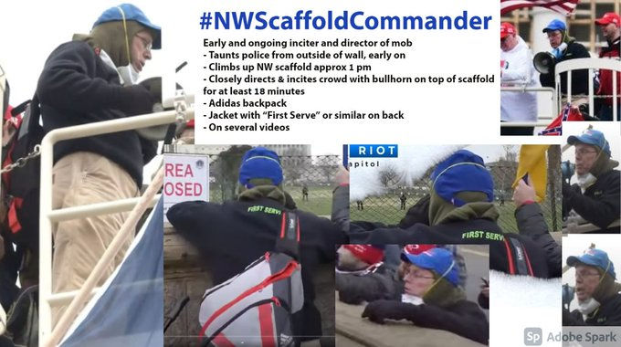

NWScaffoldCommander (we’ll call him just “ScaffoldCommander” for short) gets his name from being the ostensible “commander” of the prominent “media tower” that overlooked the Capitol’s back terrace on January 6. You’ve probably seen this tower in pictures—it’s the tall temporary structure built in November 2020 so that media crews could properly film the January 2021 inauguration ceremony. Here’s what it looks like without people around:

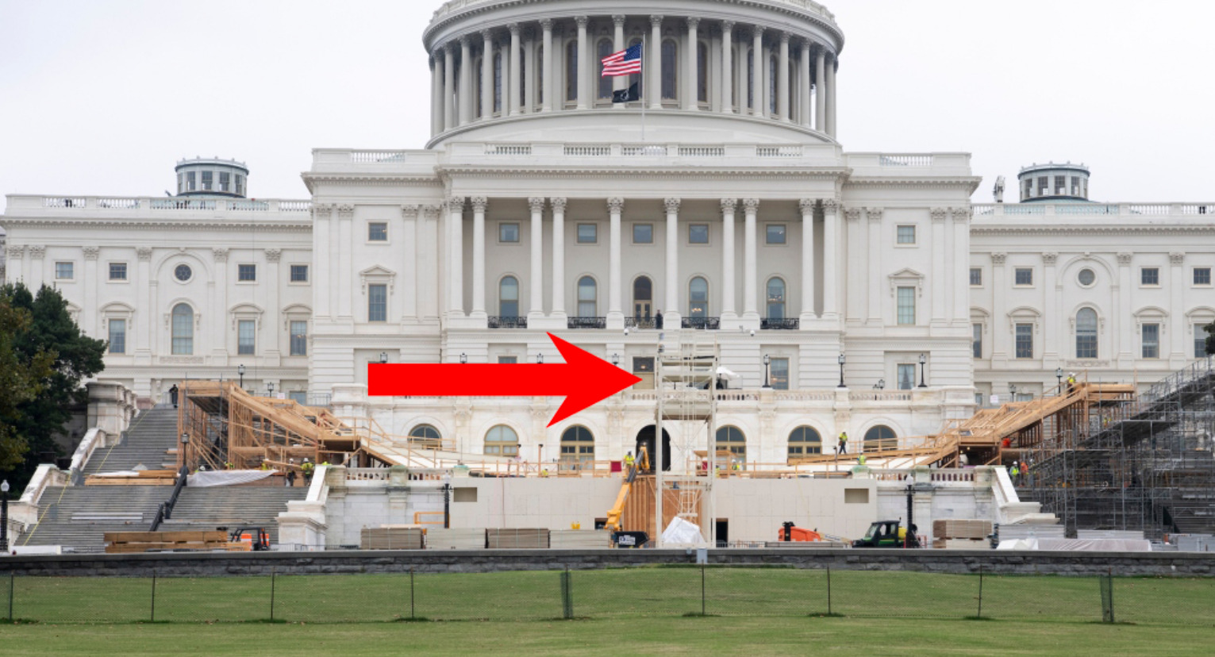

And here’s what it looked like on January 6, with ScaffoldCommander and his crew controlling it:

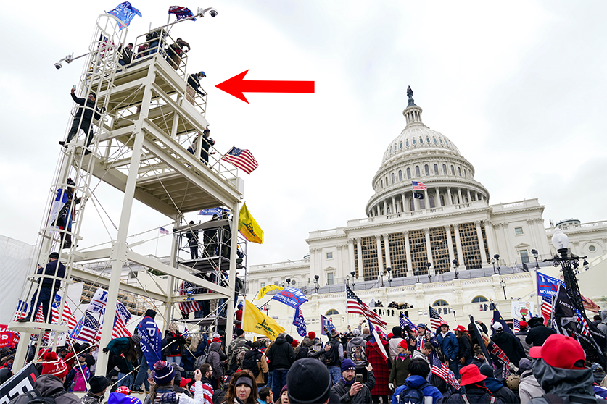

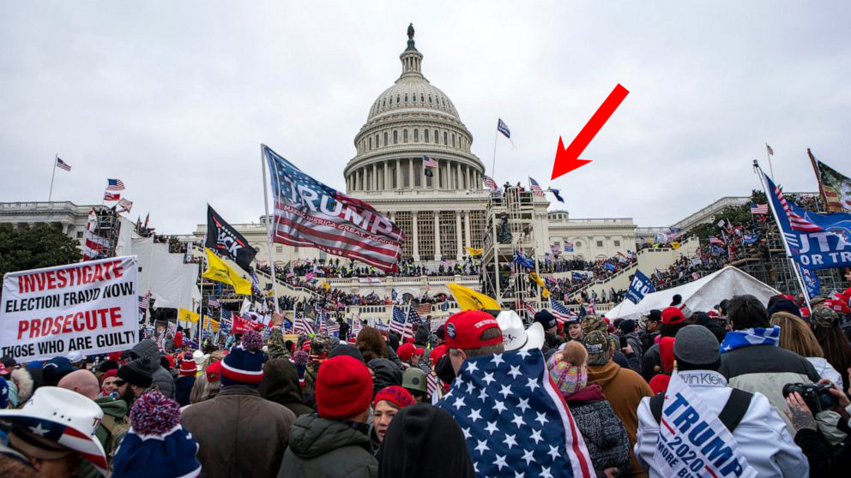

As you can see, this tower is the most perfect “command post” that anyone seeking to monitor and direct the Capitol crowd could possibly hope for. It stands front and center, everyone can see it, and the man high atop it can see and scream down to all.

One can only imagine the damage a highly aggressive and monomaniacally focused breach leader could do from this perch if he had zero scruples, a plan to attack the Capitol, and an extremely loud megaphone.

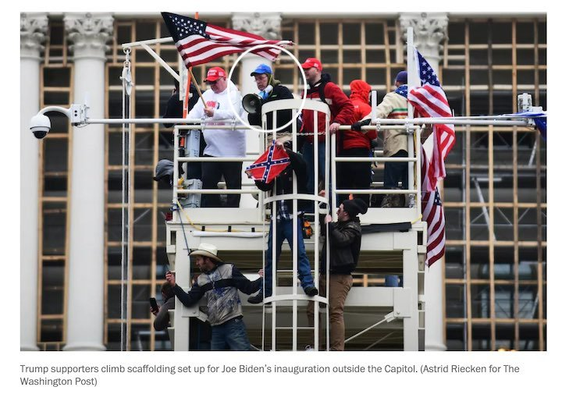

If you’ve seen any mid-day January 6 footage, you have probably seen ScaffoldCommander in action without knowing it.

From high atop the tower between 1 p.m. – 2:30 p.m, ScaffoldCommander issued the iconic bellows and non-stop commands that are loud and clear on almost every video clip from January 6 filmed in that time interval. For nearly 90 minutes straight, he bombards the otherwise leaderless crowd below him with endless variations on a single instruction: **“Don’t just stand there. Keep moving forward!”**

Watch: [At this point there's a 32sec clip saying "…. C'mon cowboys ….. It is still available [here](https://www.revolver.news/2021/12/damning-new-details-massive-web-unindicted-operators-january-6/) on 20220615. –FNC]

But once the crowd had continuously “moved forward” for over an hour, and the very first handful of rioters entered the building, ScaffoldCommander suddenly threw the switch: **“Okay we’re in! We’re in! Come on! We gotta fill up the Capitol! Come on! Come now! We need help We gotta fill up the Capitol! They got in.”**

This clip below is checkmate. **It should make ScaffoldCommander one of the top criminal suspects on the entire FBI Capitol Most Wanted List** (spoiler alert: [he isn’t even on the list](https://www.fbi.gov/wanted/capitol-violence), and no charges have been filed, and the FBI to date has still never acknowledged his existence).

Watch: [At this point there's a 31sec clip showing ScaffoldCommander saying the above. It is still available [here](https://www.revolver.news/2021/12/damning-new-details-massive-web-unindicted-operators-january-6/) on 20220615. –FNC]

For perspective, it’s important to step into the shoes of January 6 rallygoers to see just how dominant and pervasive ScaffoldCommander’s influence was over the crowd’s psychology the entire time.

Rallygoers could hear his confident and constant commands with total clarity all the way back at the entrance to the Capitol lawn. For new entrants arriving at the Capitol grounds, ScaffoldCommander’s voice would be the first and loudest voice they heard. ScaffoldCommander even mixed in damsel-in-distress type appeals so new arrivals would perceive that “moving forward” would be doing their part to rescue innocent Trump supporters who “need your help”.

Watch: [At this point there's a 15sec clip showing ScaffoldCommander from a distance, saying the above. It is still available [here](https://www.revolver.news/2021/12/damning-new-details-massive-web-unindicted-operators-january-6/) on 20220615. –FNC]

His high-pressure megaphone instructions were a constant mental and social pressure on a captive audience who was there for an entirely different reason: to peacefully participate in what they were told was a lawful Trump rally. But a loud, authoritative voice literally coming from “on high,” pleading that people “need your help,” and asking you to simply and lawfully “move forward,” creates a strong suction effect to comply with authority.

One attendee described this unnatural pressure in a vividly detailed [Twitter thread](https://twitter.com/Twinity5/status/1349188166025097220) a few days after January 6. She fingered ScaffoldCommander as “[the ringleader](https://twitter.com/Twinity5/status/1347346378545049600)” of the operation.

Another attendee who was later arrested said he [was just following the instructions of the man with the bullhorn](https://twitter.com/MacFarlaneNews/status/1403734335002267648) yelling “Patriots move forward.” That would be ScaffoldCommander. But the [FBI affidavit](https://extremism.gwu.edu/sites/g/files/zaxdzs2191/f/Stacy%20Wade%20Hager%20Statement%20of%20Facts.pdf#page=5) refuses to mention the tower commander with a giant bullhorn shouting at tens of thousands of people to “Fill up the Capitol” for 90 minutes straight because, according to the FBI, [he doesn’t exist](https://www.fbi.gov/wanted/capitol-violence).

But the clip below is, perhaps, the dead giveaway into what was truly going on. Here, a second man in the tower — the similarly unindicted “[#TowerManMale19](https://jan6attack.com/individuals/towermanmale19/index.htm)” — begins to read a prepared, hand-printed speech out loud to the crowd. The speech was sappy and idealistic, waxing philosophical about how cancel culture is bad and election processes need reform. But ScaffoldCommander had no interest in letting the bullhorn be used to communicate Trump-aligned concerns or election-related solutions.

He quickly grew angry and chastised his tower associate for losing focus: **“Tell them to move forward! That’s all they need to know right now! Tell ’em to move forward!”**

Watch: [At this point there's a 17sec clip showing #TowerManMale19. It is still available [here](https://www.revolver.news/2021/12/damning-new-details-massive-web-unindicted-operators-january-6/) on 20220615. –FNC]

The statement **“that’s all they need to know *right now*“** seems to all but confirm that ScaffoldCommander **had a two-stage breach plan**, which he stuck to with monomaniacal focus. For the first 70 minutes, the only objective was to move the pawns “forward” up the board, until as much pressure as possible had been placed on the building itself. Then, once a single breacher had made it inside, he immediately hit the Bullhorn Bait-And-Switch: “Move forward” gave way to his real imperative—“**Fill up the Capitol**.”

And yet the whole time, he never gave a reason. **He was simply a man on a mission**.

We have seen this type of singular dedication before in Ray Epps—a man who was loud and insistent, aggressive but lacked conviction, had a lust for action but wanted others to do it.

Here’s a fun supercut we put together of Epps telling other protesters “We need to go inside the Capitol”—and that everything besides that singular objective was “losing focus,” “a distraction”, “doesn’t matter,” and “not what we’re here for.”  This is effectively a mirror of what ScaffoldCommander was [going to be] doing on the bullhorn above him.

[These cuts seem, at least in part, to use Epps on the day before.]

Watch: [At this point there's a 1min10sec supercut showing Ray Epps. It is still available [here](https://www.revolver.news/2021/12/damning-new-details-massive-web-unindicted-operators-january-6/) on 20220615. –FNC]

At one point, after being rhetorically blown out by kids two generations his junior, who took turns brutally mocking his Capitol attack plan, Epps tried at last to come up with a good reason. But it didn’t go well. When forced to think on his feet, he mindlessly babbled that “We need to go inside the Capitol” because “The Capitol is our enemy.”

Watch: [At this point there's a 19sec clip showing Ray Epps. It is still available [here](https://www.revolver.news/2021/12/damning-new-details-massive-web-unindicted-operators-january-6/) on 20220615. –FNC]

Epps was reduced to claiming that the building itself was the enemy. That’s what motivated the whole shebang. Everyone else was in town for a Trump rally, and Epps flew 2,300 miles from Arizona because of a vendetta against [neoclassical architecture](https://www.aoc.gov/explore-capitol-campus/buildings-grounds/neoclassical#:~:text=The%20definitive%20architectural%20style%20on,triangular%20pediments%20and%20domed%20roofs.).

But even more important than the cognitive and attitudinal similarities between Epps and ScaffoldCommander are the operational ones.

Whether wittingly or unwittingly, Epps and ScaffoldCommander formed a two-man team ***the entire afternoon***. By miraculous coincidence, Ray Epps stationed himself immediately below ScaffoldCommander at the media tower for the whole 90 minutes it took to move the crowd forward, then into the building.

In the below video, you will see Ray Epps cordially interject himself into another man’s selfie video filmed from this spot. In the footage, Epps points back at the Washington Monument, where President Trump still had 7 minutes to go in his speech, and says: “It’s good to be on the right side of history.” You can see here that Epps chose the exact spot where the base of the command tower met the front of the Capitol police line. From there, Epps would have ultimate vision into both the rowdy vanguard front-line of the crowd, and a sense from the command tower crew of what was happening with the vast throngs of people behind him.

Watch: [At this point there's a 53sec clip showing Ray Epps. It is still available [here](https://www.revolver.news/2021/12/damning-new-details-massive-web-unindicted-operators-january-6/) on 20220615. –FNC]

At the [0:35](https://rumble.com/vpveyj-ray-epps-pov-at-front-of-third-police-line-100-101-p.m..html) mark, Epps is practically underneath the command tower, just arms-length away:

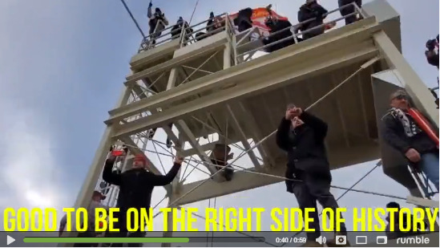

You can see from Ray Epps’s point of view just how close he is to the front of the Capitol building itself, where he has staked out a key position:

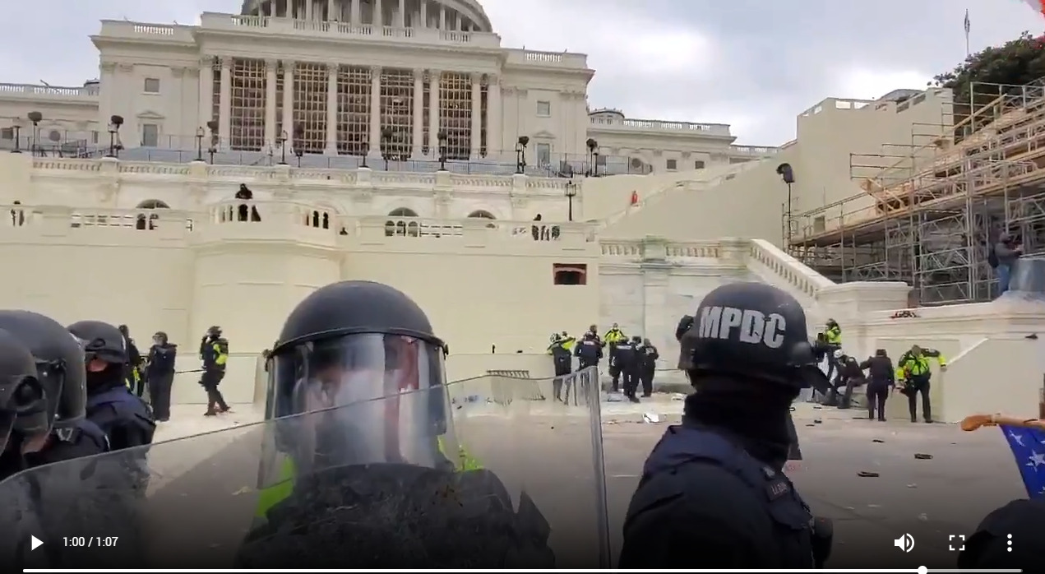

At this point the clock read 1:03 p.m., so there were still 7 minutes left in Trump’s rally speech. Yet already, an enormous and growing crowd filled the horizon. That crowd was headed toward the very spot where Ray Epps is standing. Epps pointed back proudly to where Trump was speaking and beamed with a broad smile:

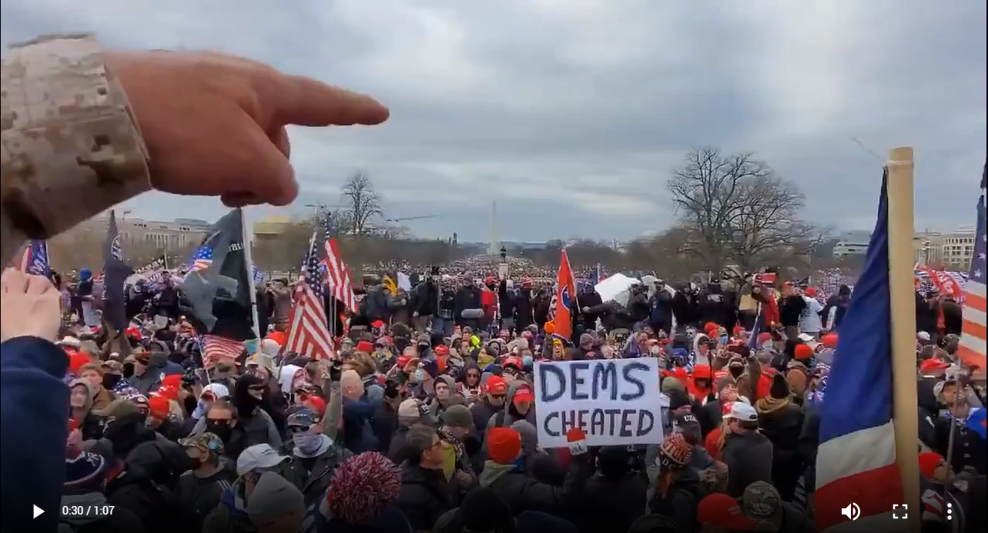

Additional footage discovered by Revolver reveals just how extensive Epps’ directorial efforts were from this key spot where the media tower met the police line.

In the clip compilation below, you will see Epps variously coordinating with a man in an orange ski mask, looking and pointing up at the media tower, retaking his spot by the tower, getting maced by police, then bellowing “Ahhh, I love it!” as he temporarily retreats from the officers’ gas attack.

Watch: [At this point there's a xxsec clip showing yyyyy. It is still available [here](https://www.revolver.news/2021/12/damning-new-details-massive-web-unindicted-operators-january-6/) on 20220615. –FNC]

The beaten down crowd looked as if it would back off the police, but Epps would simply not be denied. He stepped straight up to the police officers who had just showered the crowd in pepper spray. Epps appeared to negotiate with the officers and struck a deal, whereby Trump supporters could come back up to the front step if they simply remained there peacefully. Epps then turned back to the crowd and told them “**Guys: Listen Up. Up to the steps and stay there. We’re gonna stay there for a while.**”

Just like ScaffoldCommander above him, Epps was successfully getting the crowd to “move forward” below. In fact, at the end of this clip, you can even hear ScaffoldCommander scream “move forward” as Epps instructs the crowd to return to the top of the steps.

Watch: [At this point there's a 30sec clip showing Epps getting the crowd to “move forward”. It is still available [here](https://www.revolver.news/2021/12/damning-new-details-massive-web-unindicted-operators-january-6/) on 20220615. –FNC]

The sequence is so remarkable it’s worth highlighting its beginning, middle and end again. First, the cops spray the crowd off the steps:

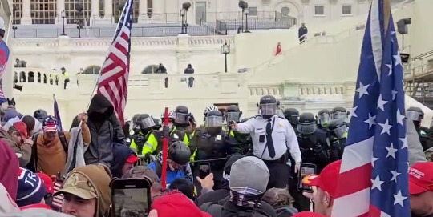

Then, Epps steps up to negotiate with police:

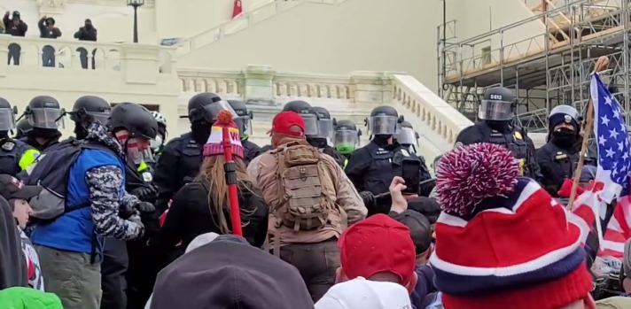

Then, like Moses returning from the mountaintop, Epps pronounces to the crowd that their Promised Land is forward at the front step of the police line:

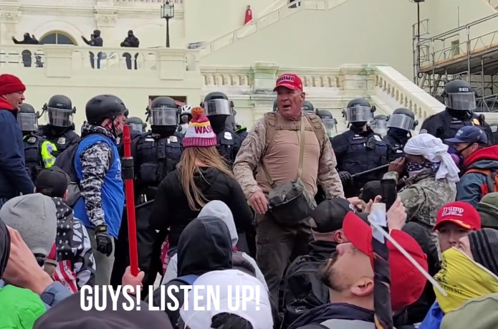

This all happened just 30 minutes before the Capitol building itself was breached. There were by then tens of thousands of people behind Epps. The following screenshot, from when the crowd [broke out in The Star-Spangled Banner](https://rumble.com/vpvx61-january-6-star-spangled-banned-140pm-western-plaza.html) behind Epps, provides a sense of the dizzying volume of human flesh impacted by how Ray Epps and ScaffoldCommander were coordinating the front line.

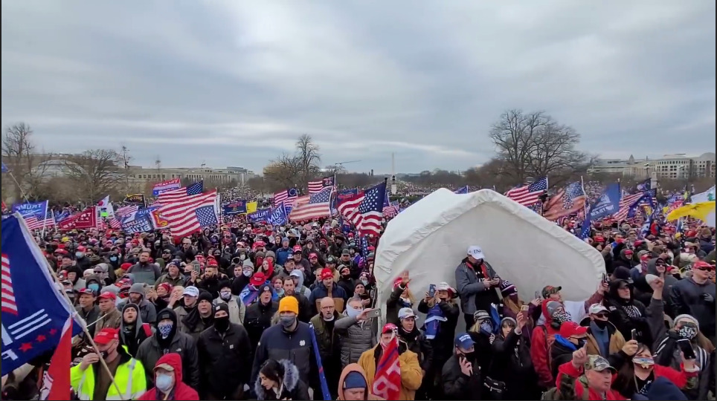

So we have ScaffoldCommander directing the body of the crowd from the tower above, and Ray Epps directing the vanguard front-liners at the police line below. Yet neither one of them has been prosecuted, nor is either presently “Wanted” by the FBI.

But what makes the ScaffoldCommander-Ray Epps affair complete is that they appeared to work in tandem from start to finish the entire day on 1/6. Both set up positions at the initial 12:50 p.m. “Big Bang” breach site, and they did so *before the Proud Boys arrived.*[The official story](https://youtu.be/jWJVMoe7OY0?t=638), you will recall, says that the Proud Boys group caused the riot. Again, we must point out how bizarre it is that so many individuals (so far Epps, ScaffoldCommander, and FenceCutterBulwark) who turn out to be key players in the Capitol breach show up in the same area so early on in the day.

Indeed, while Ray Epps was with others [antagonizing police at the front](https://rumble.com/vo7gx1-ray-epps-when-we-go-in-leave-this-here.html) of the barricades, ScaffoldCommander was antagonizing police on the lawn just meters away. This coincided almost exactly with the arrival of the Proud Boys marchers to the Peace Monument at 12:45 p.m., as if they knew the time for action was drawing near.

Watch: [At this point there's a 24sec clip showing yyyyy. It is still available [here](https://www.revolver.news/2021/12/damning-new-details-massive-web-unindicted-operators-january-6/) on 20220615. –FNC]

ScaffoldCommander then immediately leapt into action to help with fence removal as the Ray Epps Breach Team toppled the first barricades at 12:53 p.m.

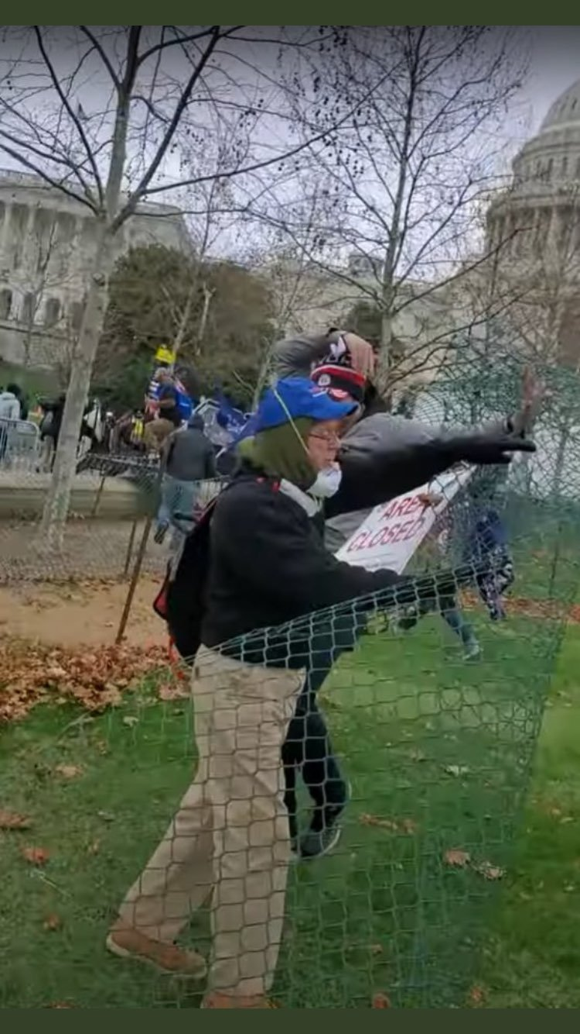

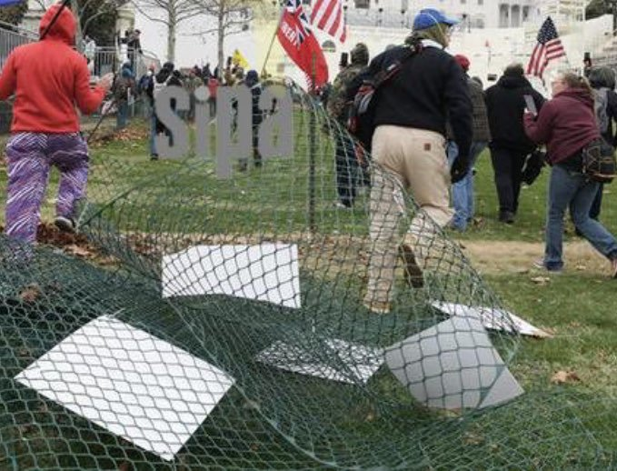

There are clear face shots of ScaffoldCommander, and he is in view for hours.

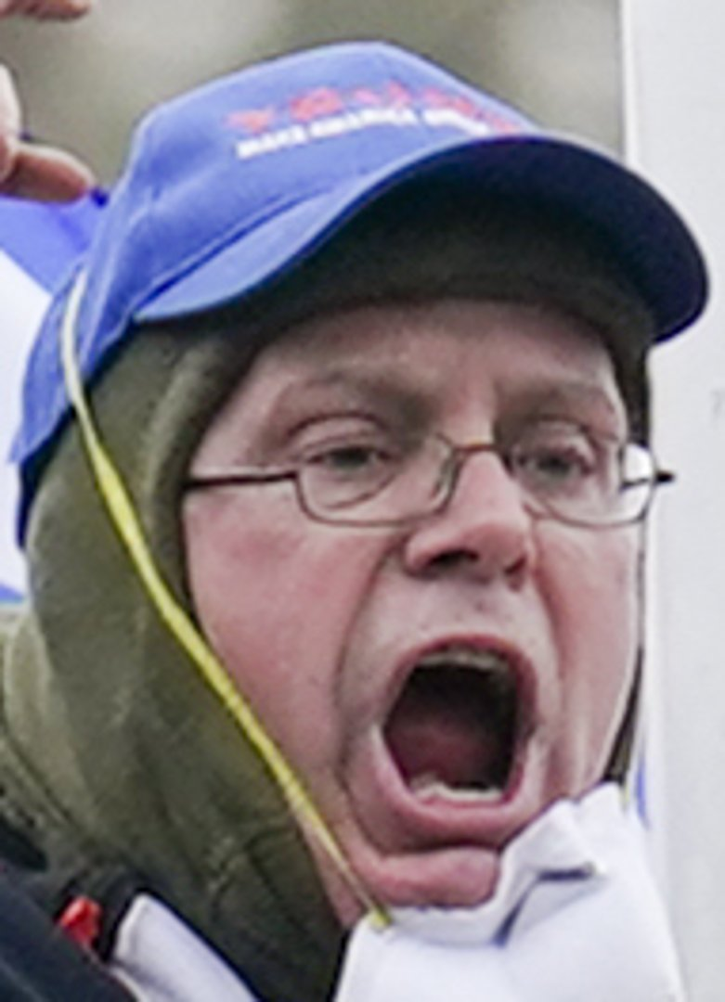  
ScaffoldCommander face shot

It is unsettling enough that law enforcement seems to be protecting key operators like ScaffoldCommander and FenceCutterBulwark. But the story gets stranger still.

ScaffoldCommander and FenceCutterBulwark were actually not the first to start removing barricades and fencing. In fact, they did not “activate” until Ray Epps’s Breach Team set off the initial attack at the Epps breach site at 12:50 p.m.

About 30 feet south of Ray Epps, right around the time the breach occurred at 12:50 p.m., a smaller squad of men were beginning the process of fence and barricade removal, out of sight of the walkway police.

Below is a video of one of the very first booby-trappers, dubbed “[#BlackSkiMask.](https://jan6attack.com/individuals/blackskimask/)” Cell phone metadata confirms a timestamp of 12:53 p.m., meaning BlackSkiMask’s efforts to open up the lawn overlapped with *the precise minute* that Epps took on the police.

You’ll note a familiar pattern: the crowd is begging BlackSkiMask to stop breaking the law, just like [they rejected Ray Epps](https://rumble.com/vo7hcn-ray-epps-shouted-down-as-a-fed-jan-5.html) the night before.

Watch: [At this point there's a 17sec clip showing yyyyy. It is still available [here](https://www.revolver.news/2021/12/damning-new-details-massive-web-unindicted-operators-january-6/) on 20220615. –FNC]

As the above video ends, BlackSkiMask sees Ray Epps and his team have successfully breached the police line. He then runs over to the walkway Epps has just cleared. From there, BlackSkiMask begins methodically dumping the police barricades over the side of the walkway wall. This clean removal process will create the impression to the 15,000 people already walking from the Trump speech that no police barricades were ever there in the first place.

BlackSkiMask is the individual you will see at 0:24 say: “**We’re taking that s**t today.”**

Watch: [At this point there's a 1min04sec clip showing BlackSkiMask. It is still available [here](https://www.revolver.news/2021/12/damning-new-details-massive-web-unindicted-operators-january-6/) on 20220615. –FNC]

In Part 1, we described how [the official story says an individual named Ryan Samsel started the riot](https://archive.fo/7qOae#selection-12431.119-12431.218) by pushing the barricades first.

But in the above video, you can see that BlackSkiMask quickly ends up *ahead* of Ryan Samsel in rushing up to the second police barricades (and both are behind Ray Epps). BlackSkiMask seemed, much more than Samsel, to know what the game plan was for the next phase of the breach.

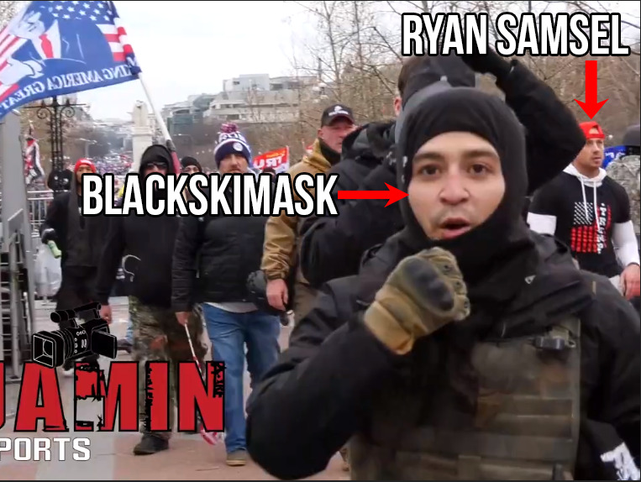

BlackSkiMask has still not been arrested. He remains on the FBI Capitol Most Wanted List, as [Suspect #148](https://www.fbi.gov/wanted/capitol-violence-images/capitol-148.jpg/view).

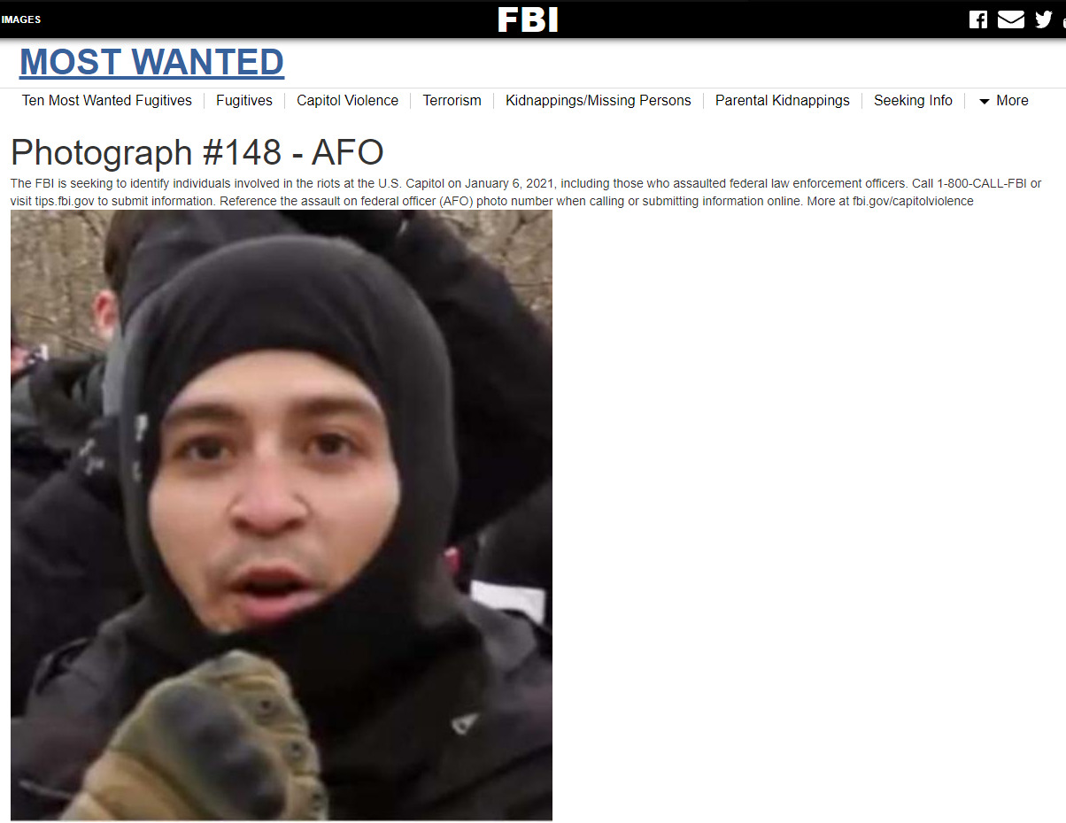

But there’s just one problem with this situation: **the FBI knows exactly who BlackSkiMask is already. And for some reason, they’re still not prosecuting him.**

The feds don’t just have an ID on BlackSkiMask, they have an entire police report—and a shocking one at that. Just one day before January 6, BlackSkiMask was yanked out of a bus by dozens of police officers who suspected his vehicle was packed with guns and bombs. His bus was stopped just in front of the US Justice Department.

Yes, read that again. You’re probably wondering why you’ve never heard of this January 5 guns-and-explosives bus anywhere in regime media. We’ll get to that below, but first watch BlackSkiMask and his two bus buddies being interviewed after their colorful vehicle from North Carolina was swarmed by downtown DC police. BlackSkiMask (who begins speaking at 0:48 below) appears reticent to give specifics on what happened, but says police pulled them all out of the vehicle, questioned them, and asked for their DNA swab samples to match their identities to prints found on firearms and potential explosives.

Watch: [At this point there's a 1min53sec interesting clip about this bus. It is still available [here](https://www.revolver.news/2021/12/damning-new-details-massive-web-unindicted-operators-january-6/) on 20220615. –FNC]

The details of this video means there must be — as a matter of law — a filed police report with BlackMaskSki’s real legal name on it, sitting in federal law enforcement’s possession. And yet for some strange reason, 11 months after January 6, the FBI is not prosecuting this man for any of the myriad felonies and conspiracy charges any US Attorney could present as a lay-up indictment. Instead, BlackSkiMask remains protected in the strange purgatory of the FBI Capitol Most Wanted List—just like Ray Epps was before the public found out his identity, after which the FBI [purged and deleted](https://www.revolver.news/2021/10/meet-ray-epps-the-fed-protected-provocateur-who-appears-to-have-led-the-very-first-1-6-attack-on-the-u-s-capitol/) his files, then denied all knowledge of his existence.

The existence of a police report means you don’t even need all the crystal-clear [4K HD face shots](https://imgur.com/a/kuKl1SG) of BlackSkiMask floating around, showing his face, his build, and his associates from every angle.

Now ask yourself: had you ever heard about this gun-filled, possibly bomb-filled “Hippies for Trump” bus the feds stopped in front of the Justice Department before Revolver just told you about it?

You probably didn’t, because the event went ***completely***unreported by DC media the day before January 6, and in the aftermath that followed. The only contemporaneous report Revolver found was a single blue-check Twitter account, whose tweets on the bizarre event are reproduced in screenshots and videos below.

First the bus [drives slowly past DC Police Headquarters](https://twitter.com/aletweetsnews/status/1346534460657987586) at 2:10 p.m, then is quickly stopped and swarming with agents in at least eight separate police cars and vans:

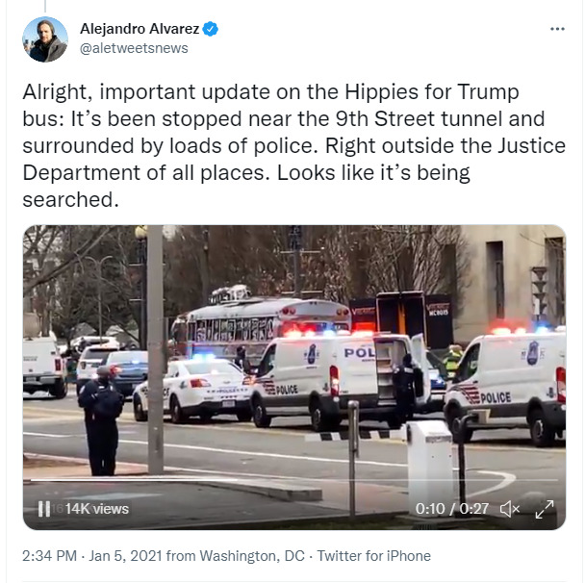

Video: [At this point there's a 26sec clip showing yyyyy. It is still available [here](https://www.revolver.news/2021/12/damning-new-details-massive-web-unindicted-operators-january-6/) on 20220615. –FNC]

By 2:57 p.m. police were standing top of the bus taking the roof apart, with bomb-sniffing K-9 dog squads at the bus’s base:

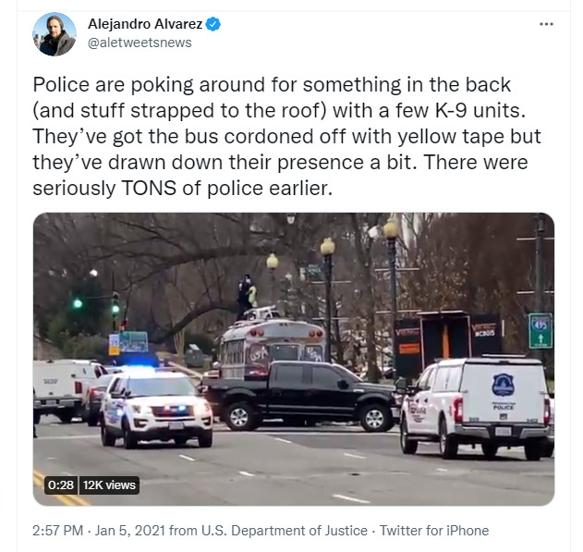

Video: [At this point there's a 30sec clip showing dog sniffing under the bus. It is still available [here](https://www.revolver.news/2021/12/damning-new-details-massive-web-unindicted-operators-january-6/) on 20220615. –FNC]

So this happened in broad daylight, with traffic stopped for likely over an hour, right in the heart of downtown DC, the day before January 6. A man from this bus is one of the very first “insurrectionists” on the scene in the Capitol, and is removing barricades before the official story says the illegal activities started.

And yet, today, the [search engine results](https://imgur.com/a/TkmLTJK) for BlackSkiMask’s terror scare are effectively nonexistent—you have to read [local North Carolina papers](https://pulse.ncpolicywatch.org/2021/01/07/hippies-for-trump-asheville-man-among-nine-north-carolinians-arrested-for-right-wing-insurrection-at-u-s-capitol/) to eek out scant details.

How could there be a total media blackout on January 5 about a guns-and-explosives cache discovery in a bus parked in front of the US Justice Department, just one day before the major Trump rally and all-important Senate certification vote?

DC is a [93% Democrat-voting](https://www.politico.com/2020-election/results/washington-dc/) bastion. Authorities would normally be stampeding toward the closest press podium to give frothing DC journalists all the salacious details of a catch like this. The responding officers would all be given promotions and medals. We are talking about busting a bus-full of “Trump supporters” with guns and explosives in broad daylight, parked in front of the Justice Department. **Why was there total radio silence?** Who ordered the story squashed? Did top brass in DC or federal law enforcement intervene to keep the story quiet—that way the next day’s events on January 6 would more convincingly look like they took DC police completely be surprise?

Remember, this was January 5. We know then-Capitol Police Chief Stephen Sund made an urgent request for back-up personnel on January 4, [but was denied](https://archive.fo/MDLZa#selection-3227.14-3227.174).  He pled to have a “state of emergency” declared at the Capitol on January 4, [but was denied](https://archive.fo/MDLZa#selection-3357.0-3357.151). Yet the very next day, on January 5, guns and explosives rolled past DC police headquarters, parked at the Justice Department, got swarmed by dozens of officers, agents and bomb-sniffing dogs, and the Capitol Police Chief’s support requests still got denied?

Did the Capitol Police even know about the guns-and-explosives bus? Was the incident kept hidden from them too?

We know with high probability BlackSkiMask’s colorful bus was headed for the Capitol rally. It had the words “Stop The Steal” and “Trump 2020” graffiti’d on it in bright paint:

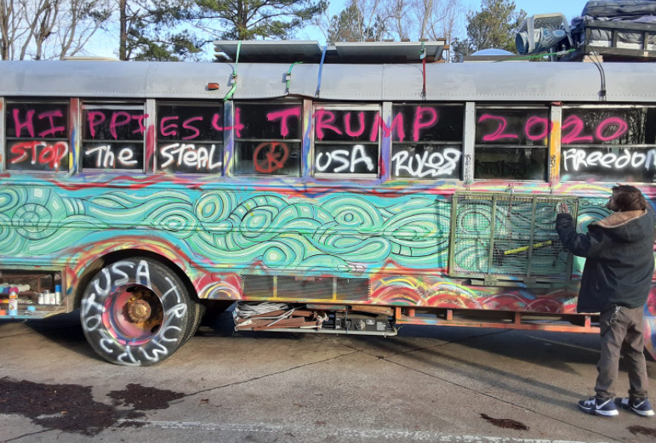

**The fact that BlackSkiMask, one of the very first January 6 breach team operators alongside Ray Epps, was pulled out of this bus, shaken down for DNA samples, mysteriously let go, and remains an unprosecuted face on the “Most Wanted List” 11 months later raises extraordinary questions for the Justice Department as to whether BlackSkiMask is being protected just like Ray Epps.**

Based on the badge on his tactical gear (see also [his extraordinary comms equipment](https://imgur.com/a/YgPUQxA)), it appears BlackSkiMask is from Texas. Like Ray Epps traveling 2,300 miles from Arizona, we are talking about “Trump supporters” who flew thousands of miles for a Trump rally but skipped the actual rally to commit a pointless barricade break-in instead.

But even BlackSkiMask was not the first person to trespass onto the restricted Capitol lawn while the Ray Epps Breach Team was leading the frontal assault. That “first on the field” distinction, some Capitol researchers believe, belongs to yet another unindicted man, also missing from the FBI’s “Wanted” list. We will now close out our roster of key unindicted breach figures with one final profile of this man, dubbed “[#BeCivilGuy](https://jan6attack.com/individuals/becivilguy/).”

The name comes from the man’s strange actions after Ray Epps & Co. overran the barricades. BeCivilGuy appears to shout “follow me” and “move down,” as in “move down” the walkway to the next police barricade. He repeatedly and quite muscularly implored the crowd to “Be Civil” as they as did so. He is the man with the blue and white bullhorn at the 0:06 second mark, a few seconds before ScaffoldComander throws his hands up and shouts “Come on!”

Watch: [At this point there's a 18sec clip showing #BeCivilGuy. It is still available [here](https://www.revolver.news/2021/12/damning-new-details-massive-web-unindicted-operators-january-6/) on 20220615. –FNC]

One has to wonder, were these [White & Blue] megaphones simply handed out as standard issue? How come so many key operators using blue-and-white megaphones and are still unindicted, 11 months later?

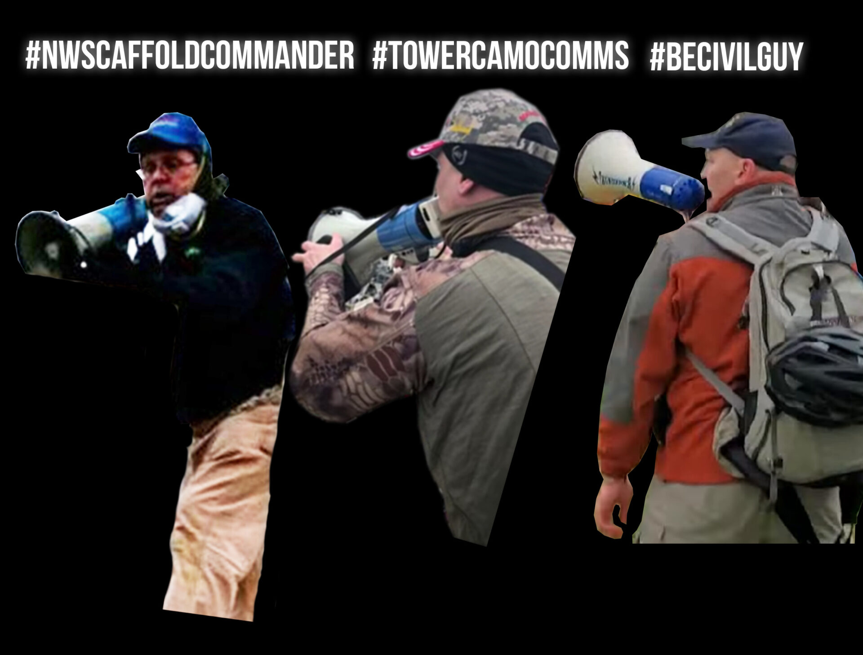  
FED-Protected White & Blue megaphoned Guys

But we digress. If all you saw was the above video, you’d think BeCivilGuy was just being helpful by urging people to “Be Civil.”

But there’s a big problem with that theory: BeCivilGuy was the first guy who broke upfield toward the second police line, way past the “Restricted Area” fencing — and he did so *before* Ray Epps & Co. breached the first police line at 12:50 p.m., and *before* any fencing came down from the efforts of BlackSkiMask and his team.

How do we know that? See the below image, which is from just 30 seconds before Ray Epps & Co. will breach the first police line and streams of people will shoot up the walkway. You will see BeCivilGuy is first and farthest up the field. At this moment in time, no breach has happened yet, no officers have been harmed or forced back, and there is no guarantee that the Trump rally will get out of hand that day, as no barricades have yet been pushed over.

At this moment in time below, immediately before the breach, BeCivilGuy is the deepest “trespasser” of any of the tens of thousands of Trump supporters in DC.

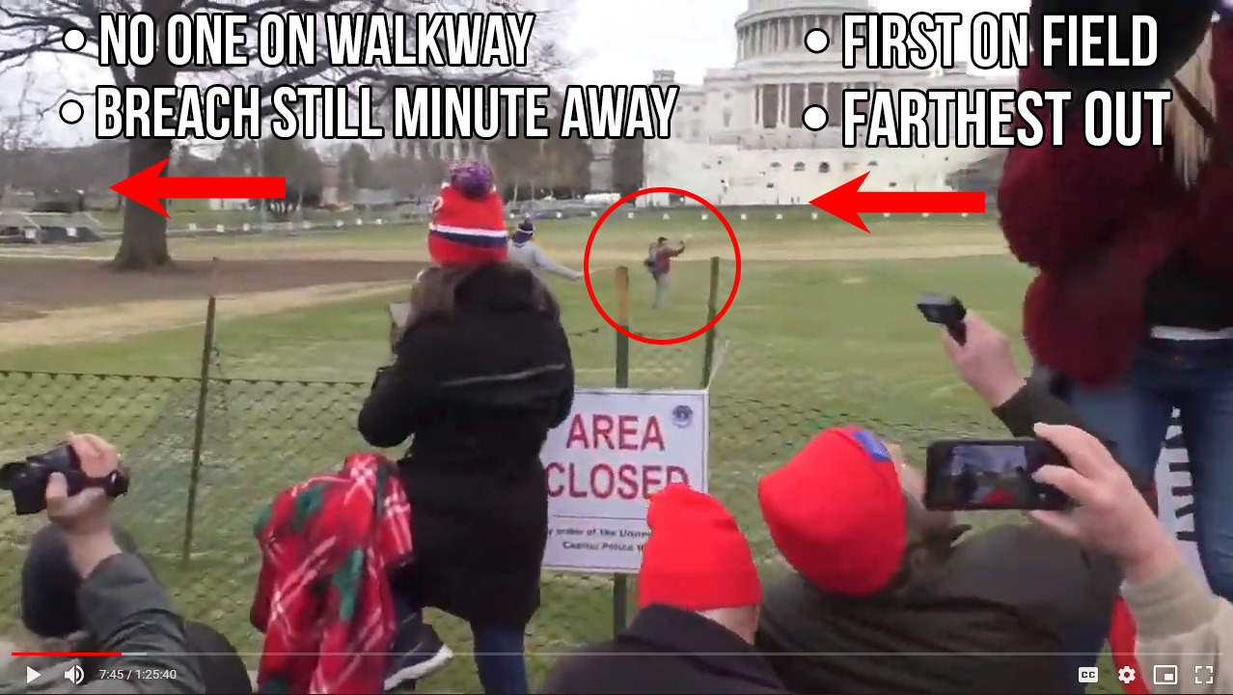

While BeCivilGuy did his Braveheart march up the lawn, breach operators like BlackSkiMask were far behind him, hugging close to the perimeter fences they had begun removing:

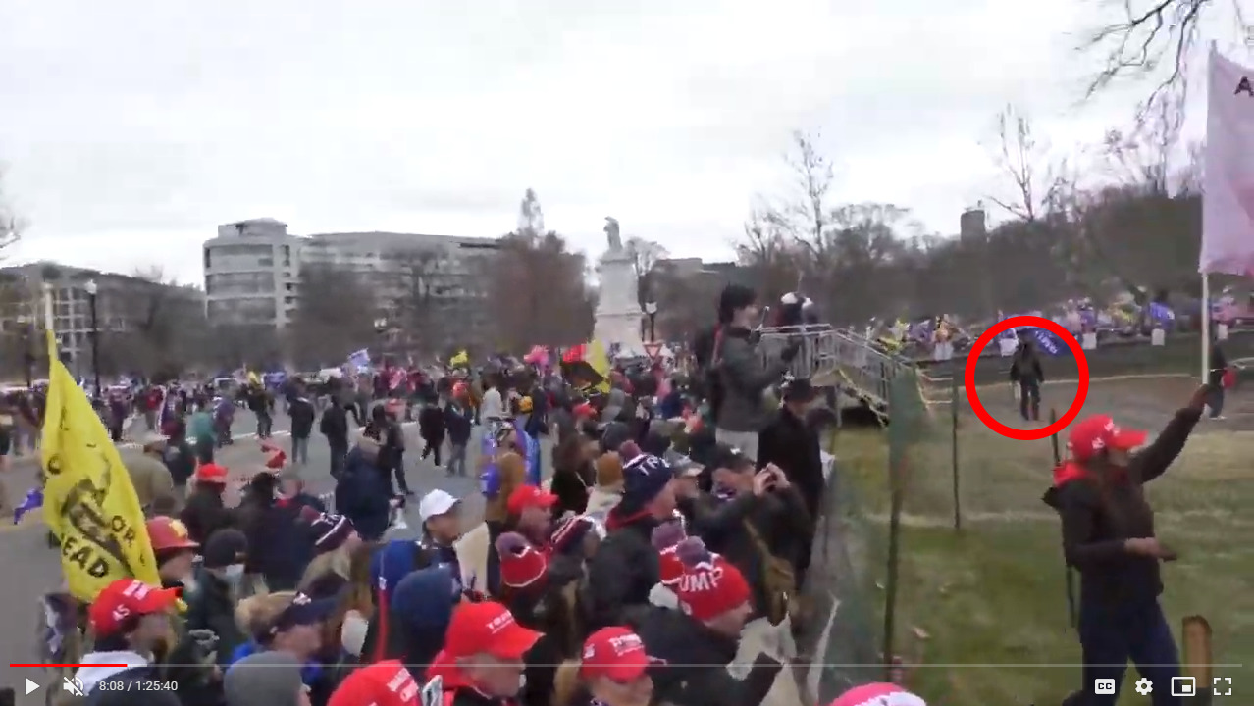

Yet while everyone else was fixated left, at the drama of the Ray Epps Breach Team, BeCivilGuy was bolting right, toward a separate Capitol Police team. Here you see him approach them with his hands up trying to flag them down:

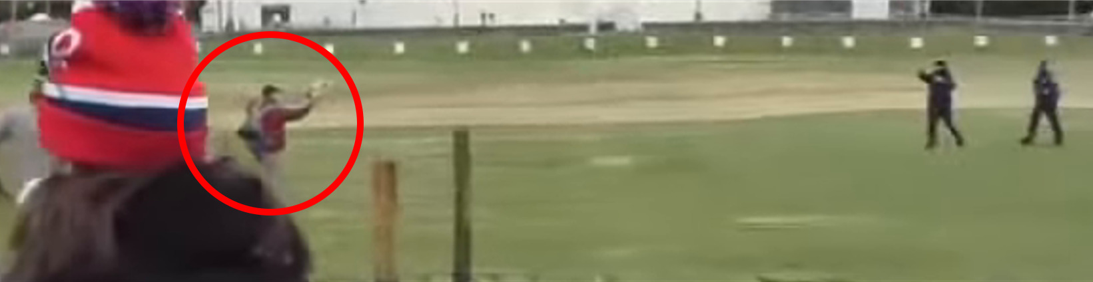

Now remember, this is happening *before* the barricade breach would afford safety in numbers to people running up the lawn. Bystanders behind the perimeter fence openly warned that those on the lawn [“don’t realize they will be shot.”](https://rumble.com/vpx54l-blackskimask-1253-p.m.-barricade-takedown.html?t=15)

So what explains BeCivilGuy’s bravery (or insanity)? What motivated him to illegally trespass way up the lawn by himself, then wave down a whole squad of Capitol Cops stationed at the second perimeter, before the first police perimeter line had even been breached yet?

What kind of January 6 protester is so “extremist” he brings a giant bullhorn to the rally, then risks death as the first man to illegally [bum-rush](https://youtu.be/ClGXIaPZzOw?t=64) the Capitol lawn, but is also so “anti-extremist” he blows off Trump’s final speech in office, and uses his bullhorn to play hall monitor to a minor side crowd? And if he wanted to stop the crowd’s lawbreaking, why didn’t he tell the crowd to “move back” behind the first barricades, instead of telling them “come down” to the inner perimeter of the next police line?

If you didn’t know any better, you’d think BeCivilGuy was some kind of undercover plainclothes Secret Service agent who knew a breach was about to happen — and he rushed up the lawn to warn U.S. Capitol Police.

But one can only imagine what would happen to The Narrative if “the very first insurrectionist to illegally invade the hallowed Capitol grounds” was just an undercover Fed with foreknowledge.

We don’t know whether that’s true with BeCivilGuy, and ultimately, only the Justice Department can tell us. But a subsequent sequence in which he’s the star raises unsettling questions.

In the below clip, BeCivilGuy rushes in to stop another man from breaking a window at the Western Plaza. The full context of the window-breaking is [available here with an incredible clip](https://rumble.com/vq7rts-becivilguy-takes-down-cartharttwasp-as-crowd-yells-to-stop.html) of the crowd yet again urging Capitol protesters to refrain from breaking the law. For our purposes, BeCivilGuy’s appearance begins at 0:20, but we’ve left in the first 20 seconds for context.

Watch: [At this point there's a 43sec clip showing BeCivilGuy beginning @ 20 sec. It is still available [here](https://www.revolver.news/2021/12/damning-new-details-massive-web-unindicted-operators-january-6/) on 20220615. –FNC]

Three important things deserve mention:

First, note how professional BeCivilGuy is with his physicality. He has no fear at all seizing a beefy ski-masked man wielding a crowbar by the scruff of his neck, neutralizing him, and dressing him down. At [0:23](https://rumble.com/vq7r7a-becivilguy-were-getting-in.html) above, you’ll see BeCivilGuy actually pat down the man’s chest before seizing his collar, as if his instinctive second nature was to do a law enforcement “pat down” on the perp to see if he has more weapons or a firearm. BeCivilGuy, like Ray Epps, is an absolute “alpha” at crowd control. In a word, he seems professional.

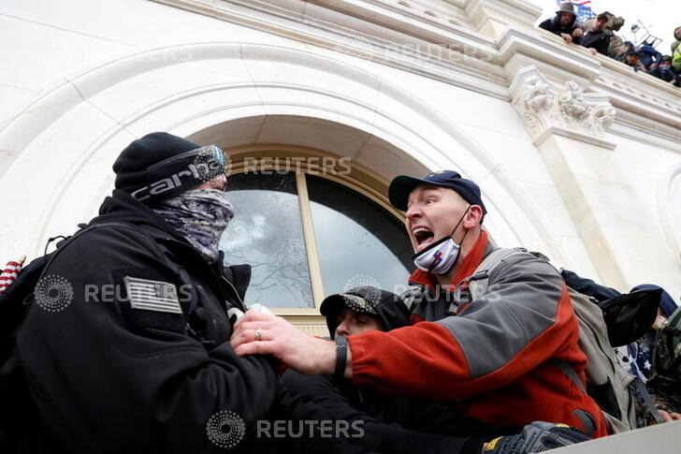  
BeCivilGuy seems professional

Second, and much more importantly, **BeCivilGuy was not trying to stop people going in the Capitol**. This sequence happened at 2:56 p.m. The Capitol had been already breached more than 40 minutes earlier, first at [2:12 p.m.](https://en.wikipedia.org/wiki/Timeline_of_the_2021_United_States_Capitol_attack) The front main entrance to the Capitol was already wide open, with hundreds simply walking in the front door and staying within the velvet ropes, by [2:25 p.m.](https://youtu.be/jWJVMoe7OY0?t=1369)

And we know BeCivilGuy knows this, because at [0:39](https://rumble.com/vq7r7a-becivilguy-were-getting-in.html), BeCivilGuy points to the other side of the Capitol and reassures the window-breaker’s associate that “**We’re getting in. We’re getting in.**” BeCivilGuy either wanted, or was fine with, Trump supporters going inside the Capitol. He just wanted people to do so ***peacefully***.

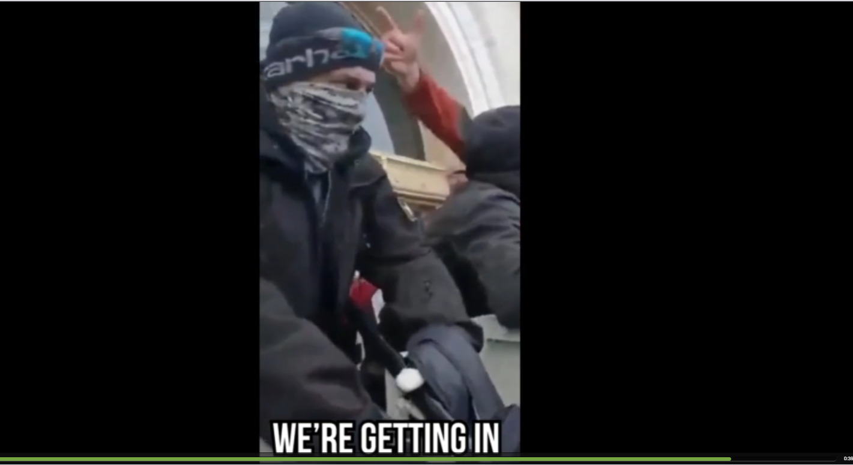

This is effectively a carbon copy of the strange modus operandi of Ray Epps.

As we described in our October report:

If you want to see what this walking philosophical paradox looks like in action, here’s a clip of Epps patrolling the very front police lines of the Capitol’s Western Plaza at approximately 3:15 p.m at the height of the day’s mania — nearly two and a half hours after Epps and his “breach team” appeared to coordinate the toppling of the Capitol’s East-side police barricades. This was also nearly a full hour after the US Capitol building itself had already been breached. With Epps’s stated mission of breaching the Capitol accomplished, and hundreds of Trump supporters already inside, Epps’s mission magically switched to calming the crowd down, assuring them “We already made our point,” and ensuring that no more of his apparently fellow officers got hurt that afternoon:

Watch: [At this point there's a 31sec clip showing Ray Epps mediating between crowd & Police. It is still available [here](https://www.revolver.news/2021/12/damning-new-details-massive-web-unindicted-operators-january-6/) on 20220615. –FNC]

Ray Epps told his local Arizona newspaper just five days after January 6 that going into the Capitol “peacefully” meant “we would go in the doors like everyone else”—and not break windows doing so. BeCivilGuy seems to be following the exact same playbook, or perhaps instructions, as Ray Epps.

As AZCentral [reported:](https://www.azcentral.com/story/news/local/arizona/2021/01/11/fbi-capitol-investigation-arizona-trump-supporter/6624406002/)

**When read a transcript of the comments, [Epps] said, “The only thing that meant is we would go in the doors like everyone else. It was totally, totally wrong the way they went in.”**

To compound the mystery, even the man BeCivilGuy stops from breaking the Capitol glass at 2:56 p.m. is unindicted. He remains safe in the bosom of the FBI Capitol Most Wanted List, as [Suspect #283](https://www.fbi.gov/wanted/capitol-violence-images/capitol-283c.jpg/view), despite a full face doxx and thousands of hours of footage the Feds could use to track his movements and associates. You’d think he’d be a priority given he’s smashing windows with a crowbar and frequently seen speaking into an earpiece.

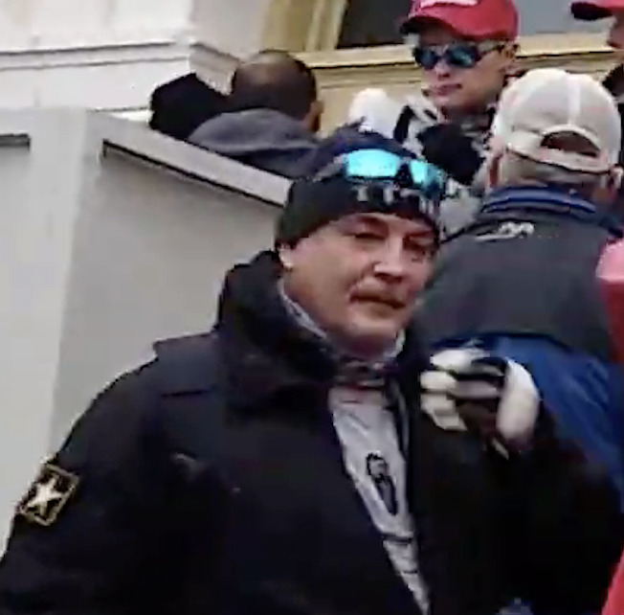

However, at this point, too little information about this man dubbed “[#CarharttWasp](https://jan6attack.com/individuals/carharttwasp/)” is known to form an educated opinion into how he fits into the larger picture. We simply point out his interaction with BeCivilGuy, because of the latter’s role in being first up the field in the Ray Epps Breach Team.

**Ray Epps Saw It All Coming**

Any simple study of Revolver’s Ray Epps video library confirms, beyond all reasonable doubt, that **Ray Epps had advance knowledge of a Capitol perimeter breach that would occur where and when it did, on January 6.**

In one telling exchange on January 5, after Ray Epps told the crowd “We need to go into the Capitol”, a young man insulted Epps, then finally hurled invective: **“You’re not gonna do sh*t. You’re not gonna storm the Capitol, you’re not gonna do anything.”**

A funny thing then happened: Epps looked up and away, beamed with a cocky, knowing smile, and then raised his hand in a gesture that indicated: **“Keep talking kid, you just watch and see.”**

Watch: [At this point there's a 31sec clip showing Ray Epps on January 5. It is still available [here](https://www.revolver.news/2021/12/damning-new-details-massive-web-unindicted-operators-january-6/) on 20220615. –FNC]

Epps was absolutely oozing with confidence. He appeared to know something the rest of the crowd did not.

Ray Epps was then up bright and early recruiting people to fall into his booby-trap.

In our Part 1 report, we described how prior to Epps leading the Big Bang Breach Team at 12:53 p.m., he parked himself at the entrance to the Washington Monument at 10:24 A.M.. This was the site where hundreds of thousands of Trump supporters were making their way early in the morning to get coveted lawn positions to hear their President speak.

Watch: [At this point there's a 34sec clip showing Ray Epps saying "..the Capital. It's that direction. It is still available [here](https://www.revolver.news/2021/12/damning-new-details-massive-web-unindicted-operators-january-6/) on 20220615. –FNC]

But 10:24 A.M. was an odd time for Ray Epps to be staked out at the entrance to Trump’s speaking venue. Trump was not scheduled to speak until noon, and we know from Epps’s 12:50 p.m. breach activities that he did not stick around for Trump’s speech.

Revolver has discovered multiple additional recruiting missions that Ray Epps was engaged in, dipping early into the 9 a.m. hour. Notice below how Ray Epps used the same damsel-in-distress language as ScaffoldCommander did, by saying: **“We need your help!”** Epps also made sure people knew **“The Capitol is in *that* direction”** so they wouldn’t take an unconventional or circuitous path, and thereby miss the precise walkway entrance the breach team would pry open while the masses were still at Trump’s speech.

Watch: [At this point there's a 29sec clip showing Ray Epps saying vvvvvv. It is still available [here](https://www.revolver.news/2021/12/damning-new-details-massive-web-unindicted-operators-january-6/) on 20220615. –FNC]

This means Epps came to the Trump speech early in the morning with the sole intention of recruiting a mob to follow on the heels of the Capitol breach team he would personally oversee while Trump was speaking—the very breach team we have covered in this report whose operators would remove the fencing, signage and barricades before the masses would arrive at the Capitol.

Let’s put this all in context:

Ray Epps flew 2,300 miles from Phoenix, Arizona to Washington, DC for a Trump rally, supposedly as a Trump supporter.

Epps arrived at the rally entrance more than two hours early, camped out to constantly shout recruiting instructions about coming to the Capitol after the speech, but then skipped out on the speech itself, because he was too busy personally orchestrating the Big Bang Breach Team that kicked off the riot and tore down the fencing, barricades and signage, which made rallygoers totally unaware [of the legal booby trap they had walked into.](https://extremism.gwu.edu/sites/g/files/zaxdzs2191/f/Jeremy%20Brown%20Statement%20of%20Facts.pdf#page=5)

So if Ray Epps was acting on instructions from a government handler from any federal agency (FBI, ATF, Pentagon, DHS, DEA, anything), we now are talking about **perhaps the single most egregious caught-on-camera intelligence operation in our lifetimes**.

**Synthesis: We Now Know How They Did It**

It increasingly appears that we now know how rogue elements of federal agencies pulled off the January 6 Fedsurrection. If the Ray Epps Breach Team hypothesis is correct, a group of government-sponsored provocateurs were all instructed separately by handlers to arrive at the Peace Monument before 12:45 p.m., where they front-ran the arrival of the Proud Boys, who would serve as the scapegoat for the breach. Then, post-breach, key operators such as Epps and ScaffoldCommander directed the crowd to “move forward,” while others removed barricades, fencing and signage.

There is simply no way the FBI did not know the Proud Boys march would end up at the Peace Monument just after 12:45 p.m. That march was led by Proud Boy leader Joe Biggs. Biggs [is an FBI informant](https://www.nbcnews.com/politics/national-security/fbi-enlisted-proud-boys-leader-inform-antifa-lawyer-says-n1262578) who says he “[spoke often](https://www.nbcnews.com/politics/national-security/fbi-enlisted-proud-boys-leader-inform-antifa-lawyer-says-n1262578)” with his bureau contacts. Biggs’s Proud Boy boss Enrique Tarrio [was also an FBI informant](https://www.reuters.com/article/us-usa-proudboys-leader-exclusive/exclusive-proud-boys-leader-was-prolific-informer-for-law-enforcement-idUSKBN29W1PE). And [the FBI was reading their cell phone group chat messages](https://archive.fo/u8TG4#selection-831.81-831.129) ahead of time.

Epps, for his part, may not have understood any of the bigger picture. If the [former Oath Keeper state chapter president](https://archive.fo/7qOae#selection-7877.0-7901.62) is indeed a longtime government informant, as it fully appears, he may be very much used to getting text messages from an agency contact telling him “Hey, go to this right-wing event and test the crowd for troublemakers. We’re looking to [flush out the crazies](https://web.archive.org/web/20091202065420/http:/www.northjersey.com/news/Records_show_feds_used_ultra-right_radio_host_for_years.html).” Certainly, Epps made it sound like he was no novice to crowd control at large-scale protest events. His [Facebook profile picture was a previous mass march on Washington](https://imgur.com/a/R4idCtN), and he was fond of telling those around him he’s **“been doing this a long time.”**

Watch: [At this point there's a 29sec clip showing Ray Epps saying "I've been doing this a long time.". It is still available [here](https://www.revolver.news/2021/12/damning-new-details-massive-web-unindicted-operators-january-6/) on 20220615. –FNC]

Moreover, we know Ray Epps feels morally conflicted about what happened. He may still consider himself a patriot, and realized only later he was used like a pawn. How else can one synthesize Epps’s cryptic and tortured quasi-confession to the[AZ Central](https://archive.fo/CuMA4) just five days after January 6, where he was torn between the statements **“I think the truth needs to get out”** and **“they were supposed to go in the doors like everyone else.”**

What “truth” did Ray Epps mean, when he said “the truth needs to get out”?  Why did Epps believe the crowd “was supposed to go in” the Capitol a certain way—i.e., through the front Columbus entrance doors, rather than breaking and entering the rear Capitol windows? **Who was Ray Epps working for, and who told him how things were “supposed” to go?**

[From AZCentral:](https://archive.fo/CuMA4)

A Queen Creek man who acknowledges he was in Washington, D.C., for last week’s rally by President Donald Trump also appears to be shown in videos taken the night before talking about plans to go inside the U.S. Capitol.

In one video that has been widely viewed on Twitter, he can be heard saying, “I don’t even like to say it because I’ll be arrested. I’ll say it. We need to go into the Capitol.”

Ray Epps told The Arizona Republic in a brief telephone interview Monday that he had traveled to the capital for the event, and that he had been advised by an attorney not to speak about it.

**“I think the truth needs to get out,” he said.**

He said he would be putting out a statement on Tuesday and added, “I didn’t do anything wrong.”

A video online appears to show him saying, “We’re here to defend the Constitution” and “We need to go into the Capitol.”

Asked about it, he first told The Republic he would need to see the video. **When read a transcript of the comments, he said, “The only thing that meant is we would go in the doors like everyone else. It was totally, totally wrong the way they went in.”**

On top of the evidence above, consider this perspective. The Feds paid their bottomless roster of secret operatives a whopping $548 million [in 2020 alone](https://www.forbes.com/sites/adamandrzejewski/2021/11/18/fbi-and-other-agencies-paid-informants-548-million-in-recent-years-with-many-committing-authorized-crimes/?sh=351ac255f4dd) for sting jobs all over the country. [20 percent](https://www.forbes.com/sites/adamandrzejewski/2021/11/18/fbi-and-other-agencies-paid-informants-548-million-in-recent-years-with-many-committing-authorized-crimes/?sh=351ac255f4dd) of their informant roster is made up of “longtime informants,” who effectively make a career out of it. It’s even quite banal for longtime informants to be explicitly authorized in advance to go out and commit crimes, with federal handlers [granting permission for informants to carry out 22,800 crimes](https://www.forbes.com/sites/adamandrzejewski/2021/11/18/fbi-and-other-agencies-paid-informants-548-million-in-recent-years-with-many-committing-authorized-crimes/?sh=351ac255f4dd) in the 2011-2014 reporting period alone.

So if Ray Epps and others were granted permission by the handlers ahead of time to participate it crimes, it would not be a “big deal” inside the bureau: it would be standard operating procedure. The FBI even gave key government informant and Three Percenters chapter founder Steve Robeson [authorization to commit crimes](https://www.iosconews.com/news/state/article_fc058ec9-7792-5860-b6ec-41f764d25531.html) during the Whitmer Kidnapping Plot hoax.

We don’t have public data on the volume of pre-authorized crimes beyond 2014, but we do know that FBI Director Chris Wray [began doubling](https://www.usnews.com/news/top-news/articles/2021-09-21/us-domestic-terrorism-investigations-have-more-than-doubled-fbi-director) his “right-wing extremism investigations” in April 2020 (seven months before 1/6), the FBI and DHS issued [threat assessments](https://spectrumlocalnews.com/nys/jamestown/news/2020/10/07/white-supremacist-groups-pose-greatest-us-domestic-terror-threat) naming right-wing domestic extremist groups as the nation’s #1 top-priority law enforcement and terrorism threats in the summer of 2020, and that the FBI is [bound by DOJ guidelines](https://www.ignet.gov/sites/default/files/files/guidelines-undercover-operations-june-2013.pdf) to proportion its informant roster to its threat assessments. So if January 6 turns out to be the biggest Fed-fest in US history, we can see clearly now in retrospect how “the table was set.”

**Conclusion: The Time Is Now For Full-Court Legal and Legislative Action**

You know the fix is in because we do not have Ray Epps’s phone records from January 6.

A full and complete record of every text message, every phone call, and every wire conversation Ray Epps made on January 5-6 would tell us exactly who else was privy to the Capitol breach plan. It would also very likely tell us which federal agencies were giving the orders, and which agents in particular were handling the many disparate members of the breach team.

The sham January 6 House Select Committee has now subpoenaed [over 100 civilian cell phone records](https://www.cnn.com/2021/12/07/politics/january-6-committee-phone-records/index.html). But you know the fix is in because they have stayed away from subpoenaing the cell phone records of Ray Epps. And Ray Epps is [just chilling at home](https://rumble.com/voc5ev-fed-ray-epps-confronted-and-scurries-away-cowards-always-run.html) these days, under [the apparent protection](https://rumble.com/vql3so-phoenix-fbi-agents-visit-pure-politics-deny-knowing-ray-epps-exists.html) of the Phoenix FBI.

We know that in the FBI-orchestrated “Whitmer Kidnapping Plot,” just three months before January 6, key FBI informants received text messages from handlers to [“maximize attendance”](https://archive.fo/PjCyI#selection-4209.273-4209.292) of the patsies at locations where their presence would be construed as an “overt act” in furtherance of a conspiracy (**“agreement”** and **“overt act”** are the two legal elements of a federal conspiracy charge).

Congressional Republications must now demand the phone records and full and complete account of Ray Epps’s relationship with the federal government. Subpoenas should be flying at [Sean Kaul](https://www.fbi.gov/news/pressrel/press-releases/sean-l-kaul-named-special-agent-in-charge-of-the-phoenix-field-office), the Special Agent-in-Charge of the Phoenix FBI Field Office, faster than [Merrick Garland can run from an honest question](https://twitter.com/RepThomasMassie/status/1451272067173736455).

**January 6 defense lawyers: *you must* seek court-ordered subpoenas for discovery production related to the federal government’s records on such individuals as**

* **Ray Epps and**
* **ScaffoldCommander.**

If **Ray Epps** is a Fed, and your client walked through the Peace Monument gate or was induced to trespass because of the Big Bang Breach Team’s booby trap, you have an entrapment case and a potential affirmative defense. The Justice Department is legally required under *Brady* to provide you with all potentially exculpatory evidence related to that defense, and you should be prepared to play tapes of Ray Epps to the jury showing how the riot started in the first place.

If **ScaffoldCommander** is a Fed, and your client was induced to “move forward” and be thrust into a breaching throng, you have an entrapment case. **“Fill up the Capitol”** is a direct order. That goes far beyond the “strong suggestive language” that government informants are required to stay within in order to avoid entrapment.

Finally, Ray Epps, if you’re reading this: We know that you are conflicted, and that you want the truth to come out. You can still be a hero.

Simply come forward, and tell the world your story.

What really happened on January 6?